_________________________________________

Constraints to Growth and Employment in Durban: Evidence from the Informal Economy
_________________________________________

Caroline Skinner

Research Report No. 65

April 2005

School of Development Studies
University of KwaZulu-Natal
Howard College Campus
Durban 4041

ISBN No 1-86840-521-4

The views expressed in this Research Report should not be attributed to the School of Development Studies.

Acknowledgements
This project was funded by USAID and commissioned by the Economic Development Department of the eThekwini Municipality. Technical assistance was provided by Bala Rajaratnam. Thanks to Judith Shier, Francie Lund and Imraan Valodia for overall input and careful edits.
Table of Contents

1. Introduction 4
2. Context 5
2.2 Informal economy - definitions and recent thinking 5
2.2 The Durban context 6
2.3 Relevant and related research 7
3. Research Methodology 10
4. Characteristics of the Enterprise Owner 11
4.1 Gender, race and nationality 11
4.2 Previous work experience 13
4.3 Motivation for starting the business 14
4.4 Household size and income 14
4.5 Use of profits 16
4.6 Organisational membership 16
5. Characteristics of the Informal Enterprise 18
5.1 Age of enterprise 18
5.2 Business performance since inception 18
5.3 Fixed capital assets 19
5.4 Employment created 20
5.5 Employee working conditions and wages 22
5.6 Monthly profit 23
5.7 General business problems experienced 25
6. Business Environment and Relationship with the State 25
6.1 Location 25
6.2 Access to basic services 27
6.3 Access to transport 28
6.4 Access to communication technology 29
6.5 Safety and security 29
6.6 Registration and licences 30
6.7 Treatment by local authorities 30
7. Production and Business Management 31
7.1 Relations with suppliers 31
7.2 Relations with customers 33
7.3 Business management 34
8. Access to Financial Services and Insurance 35
8.1 Financial Services 35
Start-up funds 35
Access to credit 36
Access to savings facilities 38
8.2 Insurance 39
9. Training and Other Support Services 40
9.1 Educational background 40
9.2 Support services accessed 41
9.3 Demand for training 42
9.4 Prioritisation of support services 43
10. Priority Interventions for Local Government 44
References 49
Appendix 1: Questionnaire 53

List of Tables

Table 1: Contribution of informal economy to GDP 5
Table 2: Sector breakdown 10
Table 3: Age of enterprise owner, n=503 12
Table 4: Problems faced by women in business 13
Table 5: Those reporting total monthly income of < R1900 a month by sector 16
Table 6: Does being part of an organisation help business activities? 17
Table 7: Number of years involved in this business, n=504 18
Table 8: Percentage of respondents who had people working for them, by sector 20
Table 9: Workers, by race, gender and nature of contract 21
Table 10: Worker benefits 22
Table 11: Treatment by local authority considered a major problem by sector, n=74 31
Table 12: Source of supply by % in sector, n=503 32
Table 13: Nature of records kept 34
Table 14: Main source(s) of start up capital, n=641 36
Table 15: Main reason(s) respondent has not tried to obtain a loan or the loan application was unsuccessful 36
Table 16: Institutions that informal business owners bank with 38
Table 17: Type of insurance cover 39
Table 18: Type of insurance institution respondent belongs to 40
Table 19: Highest level of vocational training, n=151 41
Table 20: Assistance received by type and service provider, n=88 42

List of Figures

Figure 1: Business problems experienced related to demographics 12
Figure 2: Previous work 13
Figure 3:Motivation for starting this business 14
Figure 4: Total monthly income of household, n=475 15
Figure 5: Use of business profits 16
Figure 6: Organisational membership, n=267 17
Figure 7: The year the business was started, n=504 18
Figure 8:Enterprises performance 19
Figure 9: Value of assets, n=445 20
Figure 10: Changes in employment numbers over time 22
Figure 11: Weekly wage, n=100 23
Figure 12: Monthly Profit 24
Figure 13: Monthly profit by sector, sectoral percentages 24
Figure 14: General business problems experienced 25
Figure 15: Business location, current and preferred 25
Figure 16: Access to infrastructure / facilities 27
Figure 17: Problems with access to basic infrastructure 28
Figure 18: Transport-related problems 29
Figure 19: Types of crime experienced in 2001 30
Figure 20: Source of supply, n=503 32
Figure 21: Constraints related to supply of inputs and machinery 33
Figure 22: Problems related to demand for goods/services 34
Figure 23: Start-up funds, n=450 35
Figure 24: Highest level of education, percentage 41
Figure 25: Problems related to support services 43
Figure 26: Summary of issues identified as major or moderate problems 45
Figure 27: Priority interventions for local government 45

1. Introduction
This report stems from collaboration between the Durban Municipality, the World Bank and the School of Development Studies. It is one of five reports concerned with constraints to growth in the Durban economy and it concentrates on the informal component of the economy. This study builds on the substantial research - both independent and commissioned by the city - that has been conducted on the informal economy in the Durban area in the past decade. This study is unique in that it is based on a large sample - 507 interviews - and a very detailed questionnaire. An explicit attempt was made not only to capture segments of the informal economy where there are large numbers of people working – apparel, craft and traditional medicine – but also to include sectors where there is little existing knowledge - construction, metal work, crèches and hairdressing.

The objective of this report is four-fold. First, the survey allows for a detailed descriptive account of informal enterprises operating in Durban. The second objective is to critically assess what services enterprise owners and their workers have had access to in the past. The third objective is to discern informal enterprise owners’ own perceptions of constraints to growth. Informed by all of the above, the final objective is to highlight priority areas for intervention for local government.

Section 2 contextualises the research. It starts out by briefly considering recent thinking in informal economy research. It is argued that it is important to acknowledge both the relationship between informal work and poverty as well as the relationship between informal work and economic growth. A sectoral approach to the development of the informal economy is suggested. Recent trends in Durban’s economy and policy interventions are then considered. Durban has over time been identified as a city which is particularly innovative with respect to managing and supporting the informal economy. Relevant and related research is then reviewed. In Section 3 the research method and potential biases and omissions are considered. The bulk of the report consists of analysis of the data beginning in Section 4, in which the basic demographics of the enterprise owners are discussed. The characteristics of their enterprises - time in operation, assets, employment generated and profit - are then presented in section 5. Section 6 assesses the business environment and relationship with the state, while section 7 with production and business management issues. Sections 8 and 9 interrogate access to financial services and insurance and training and other support services respectively. Throughout these sections attention is paid to potential constraints to growth as well as what role local government could play to address informal operators’ primary concerns. In the final section - section 10 - priority interventions for local government are identified.

2. Context

2.2 Informal economy - definitions and recent thinking
Since Keith Hart first coined the phrase ‘informal sector’ in the early 1970s to describe the range of subsistence activities of the urban poor in Ghana, there has been considerable debate about what exactly the term refers to. Although the main writing on the definition of the informal sector differs markedly as to the relative weighting of different criteria, common to all definitions is that these are economic activities which are relatively small scale and elude certain government requirements such as registration, tax and social security obligations and health and safety regulations for workers.

There is emerging consensus that the term ‘informal sector’ disguises a significant degree of heterogeneity. Informal activities encompass different types of economic activity, different employment relations and activities with different economic potential. A second, and related, problem is the distinction between the formal and informal sectors as if there was a clear line dividing the two. There are few examples of informal operators who are not linked (either through supply of inputs or demand for goods or services) into the formal economy. Using the term informal ‘economy’ rather than informal ‘sector’ partially addresses these concerns. The term economy implies a greater range of activities than the term sector. If both formal and informal activities are seen as part of the economy we are better able to see the linkages between the two.

Internationally there is a strong correlation between poverty and participation in the informal economy. Sethuraman (1998), for example, presents multiple- country data to confirm this relationship in Latin America, Africa and Asia. This correlation appears to be mirrored in South Africa. Meth (2002:51) using Labour Force Statistics, calculates that in the 367 000 households where monthly expenditure is less than R400 per month are 1.37 million people, approximately 400 000 of whom work in the informal economy. Given the correlation between working in the informal economy and being poor there is a tendency to approach the informal economy as a poverty alleviation issue, with welfare measures being the primary policy interventions.

Research is increasingly demonstrating that cumulatively the economic contribution of these activities is significant. Table 1 below reflects some recent statistics on the contribution of the informal economy to GDP.
Table 1: Contribution of informal economy to GDP
 | Informal economy GDP as a percentage of non-agricultural GDP
North Africa | 27
Sub-Saharan Africa | 41
Latin America | 29
Asia | 31
(Source: ILO, 2002:24)

At a city level Unni and Rani (2003:59) using an innovative household cum enterprise survey methodology calculated that the informal economy generated nearly 76% of employment and 46% of the income in Ahmedabad in India. Unfortunately in South Africa the sample size of Statistics South Africa data sets that could be used to calculate the contribution of the informal economy to GDP is too small to allow for meaningful city level calculations. Budlender, Buwembo, Chobokoane, and Shabalala (2001) however estimate that the informal economy in South Africa contributes between 8-12% of gross domestic product. Durban’s Informal Economy Policy (Durban Unicity, 2000:3-4) lists a series of more sector-specific statistics demonstrating the value of turnover in different segments of the informal economy.

The point of departure of this report is that, while acknowledging that individual incomes in the informal economy are often low, these are economic activities. Leading on from this it is critical to understand first and foremost the economic dynamics in designing interventions. There is increasing consensus emerging in the informal economy research and action arena that, as is the case with the formal economy, there should be a sectoral approach to growing the informal economy (see Chen and Carr, 2002, Chen, Jhabvala and Lund, 2002). Each sector has unique economic dynamics particularly with respect to linkages with the formal economy and unique support needs.

There is a close correlation between working in the informal economy and being poor. As the informal economy contributes significantly to economic +growth, support to the informal economy provides the city with a unique potential opportunity both to alleviate poverty and to promote economic growth.

2.2 The Durban context
According to Durban’s Economic Development Department and Monitor (2000:7) only 1 in 3 economically active people in Durban is employed in the formal sector. Further, 50% of manufacturing jobs are in declining industries like footwear, clothing and textiles, printing and publishing and chemical products. In some of these sectors there is evidence of informalisation of work - see for example Skinner and Valodia’s 2002 work on processes of informalisation in the clothing industry in Durban. Monitor (2000:48) estimate that between 1996 and 1999, while employment growth in the formal economy was 1.4%, employment growth in the informal economy was between 11-19.5%. The informal economy is thus of particular importance to the Durban economy.

In the 1990’s Durban was ahead of other cities in responding to the informal work. A 1999 study assessing five different South African cities approaches to street trading, Durban stood out. Durban was the only city to have set up a separate department to oversee street trader management. Furthermore they had allocated more resources for the provision of street trader infrastructure than any other city. (Skinner, 2000). The Warwick Junction Project in Durban inner city has been widely acknowledged as successfully integrating traders into city plans. Building on this good practice, in late 1999 the City Council initiated an informal economy policy development process. The policy was developed over a year for the erstwhile North and South Central Councils and accepted in October 2000. In November 2001 it was adopted as a Unicity Policy for Durban.

In brief the policy aims to grapple with the dual challenge of governing the city as well as supporting enterprise development. It deals with them both, but separately. It acknowledges that management and support of the informal economy is a difficult task but outlines how this can be achieved through consultation with stakeholders and provision of incentives.

The policy identifies practical roles for local government in the support of small enterprises as well as for informal economy worker organisations.

Of particular relevance to this report, the policy document draws directly on trends in academic thinking with respect to how to ‘grow’ the informal economy. The document (2000:14) states the following:

‘The support function, in terms of focused efforts to help small operators take steps along the ladder towards growth and independence, should be provided through a sectoral approach, as is happening in industrial policy in support of large business. This is because each sector:
- has different economic importance to the city
- has different prospects for growth for individual operations, ranging from the limited prospects of the survivalists, to the better prospects of service providers such as hairdressers and ‘bush mechanics’
- has its own unique linkages between the formal and informal ends
- presents different problems of control (the seasonality of mielie-cooking; the hazardous chemicals in drum-selling; the noise caused by backyard panel beaters)
- offers different possibilities for support, based on all of the above.’

The Long Term Development Strategy (LTDS) drew and built on policy ideas. The supporting research and documentation that informed the LTDS quoted above identifies the informal economy as economically important. It reinforces the importance of understanding sector-specific dynamics. The report (Durban Unicity, 2001:48) however notes incomes in the informal economy are very low and suggests concentrating on ‘increasing sustainable employment of higher return’.

This study builds directly on and extends the policy suggestions made in Durban’s Informal Economy Policy and the vision outlined in the LTDS.

2.3 Relevant and related research
Substantial research has been conducted on the informal economy in South Africa. For those unfamiliar with this research this section reviews briefly background research or research to which reference is made in this report.

As Lund (1998), in her synthesis of research on street trading, noted there appears to be a disproportionate amount of research on the informal economy in KwaZulu-Natal compared to other provinces. In more recent years this has partly been a result of the City Council being proactive. The Durban local economic development (LED) studies have been modelled on the 1999 – 2000 World Bank / Johannesburg Metropolitan Council LED studies. The interview schedule for the informal economy component of Johannesburg study was adapted for this study. In view of wanting to make cross-city comparisons very few alterations were made to the questionnaire. However a series of new questions were introduced. More details were elicited about access to financial services and new questions were asked about insurance services and organisational affiliations.

Although in both studies similar questionnaires were used and the sample size was just over 500, strict comparisons cannot be made. First, the fieldwork was conducted at different times. The fieldwork in the Johannesburg study was conducted in 1999 and in the Durban study in 2002. A more serious concern however is that of the sampling strategy. Neither of the two studies used a sampling frame. Local experts made decisions about which sectors to select, as well as sample sizes in each. The sectors selected in Johannesburg were as follows: trading in food, trading in non-food products, tourism, clothing, personal services, metals, prepared foods, retail, construction, shebeens and furniture. (See Table 2 in the methodology section for the comparative breakdown by sector in this survey). It is clear that there is less of a focus on retailing in the Durban survey in comparison. There was substantial existing work on street trading and therefore existing knowledge about the constraints to growth for this group.

With respect to street trading in 1997 the Economic Development Department of the then Durban Metropolitan Council commissioned a census and survey on street trading in the Durban Metropolitan Area. The census found 19 000 street traders and in the survey over 500 street traders were interviewed. This survey gives a detailed sense of the demographics of street traders (gender, education levels, dependency ratios etc), what sectors street traders are operating in, what infrastructure they have access to and what their priority support needs are. This survey was re-analysed and supplemented by other city data by Lund in 1998.

Research was commissioned in the process of developing the informal economy policy, a number of components of which are relevant to this report. Two studies assess the infrastructure provided by the City Council to those working informally. Attwood (2000) assessed council provided market facilities both in the inner city and outlying areas. A total of 434 stall holders and 314 customers were interviewed. The report primarily focuses on the interventions necessary for improving management of these facilities. The report indicated that, particularly in the case of newer markets in outlying areas, insufficient attention had been paid to the location of markets in terms of passing feet. This reinforces the importance of solid economic analyses being conducted prior to the development of these kinds of facilities. Of further relevance to this report are questions about what stallholders felt would be of assistance to growing their businesses. Interestingly the most frequently identified support need was access to loans while very few traders identified training interventions.

Mhlongo et al (2000) analyse the developmental impact of a council facility provided to support small-scale clothing manufacturers – the Clairwood Hive. In 1996 the Council purchased a building in the Clairwood area that provides living, work and trading space for nearly 200 people. The majority of tenants manufacture work wear commonly known as pinafores. There is a significant demand for pinafores - traders come from rural areas and even neighbouring countries to source these goods. Durban appears to be a crucial trading node for pinafores. Given relatively high turnover of goods, it is an important segment of the informal economy to support. The research indicates that this facility is an important entry point both into the city and the economy for poor, unskilled people, especially African women from the Eastern Cape. However, in the absence of measures of support and a limit on tenure, there is no throughput of tenants. The building cost the Council over R2.2 million and questions have been raised about whether more effective use could have been made of these resources. The report brings into question how to most effectively and efficiently provide support to small-scale manufacturers.

A further two studies explored the formal – informal economy linkages in the fruit and vegetable and clothing industries by Witt (2000) and Motala (2000) respectively. These both highlight that traders are one point in a chain of economic activities that need to be understood, and they demonstrate the complexity of formal/informal economy relations.

The Economic Development Department in collaboration with the International Labour Organisation initiated a study on home-based work. This research project was conducted in parallel to the Informal Economy Policy development process. This qualitative, action-oriented study collected information on 78 home-based enterprises. Interviews were conducted in two areas in the city – Pinetown South and Sydenham Clare Estate and in two types of settlements – informal and township settlements. The final report (Cross et al, 2001) represents a number of concrete policy interventions. One of the strengths of this report is that it outlines the nature of home-based enterprises in informal settlements, an aspect of the informal economy that is not addressed in this or other research.

Internationally migrants, particularly those who do not have proper documentation, often have no choice but to work in the informal economy. Given political conflicts in the region, as well as South Africa’s relative economic strength, there are significant numbers of legal and illegal migrants from the region living and working in South Africa. Research indicates that foreigners, particularly from other African countries, are active in the informal economy in South Africa (see for example McDonald, Mashike and Golden, 1999; Peberdy and Crush, 1998 and Rogerson, 1997). Rogerson (1997) particularly highlights foreign owned informal enterprises as vibrant and diverse, often creating a number of jobs for South Africans as well as other foreigners. Foreigners are often held to be good entrepreneurs and thus disliked by their South African counterparts. In policy terms incorporating foreigners is thus particularly controversial.

Local research confirms foreigners’ involvement in the Durban informal economy. For example Vawda 1999, Gema 2001, Geyevu 1997, Sabet-Shargi, 1999 give insight into, among other issues, the work activities of Senegalese and Malawian, Ethiopian, Ghanaian and Congolese refugees respectively and Hunter and Skinner, 2002 on foreign street traders in the inner-city. As Hunter and Skinner (2002) point out further work needs to be done on understanding the broader economic contribution being made by this group to the Durban economy.

3. Research Methodology
Between January and April 2002, 507 interviews were conducted with informal enterprise owners operating in the Durban municipal areas. Informal enterprises were defined as enterprises that are not registered to pay value added tax (VAT).

A census of all informal economic activities in the Durban area has never been conducted, so a representative sample could not be drawn. The research approach was to identify sectors that are known to be significant segments of the Durban informal economy in terms of employment and economic contribution. The sectors selected, as well as the sample sizes in each sector are represented in Table 2 below.
Table 2: Sector breakdown
 | Frequency | Percent
Apparel | 82 | 16.2
Craft | 80 | 15.8
Traditional medicine | 80 | 15.8
Spaza shops | 62 | 12.2
Construction | 39 | 7.7
Metal work | 43 | 8.5
Shebeens | 41 | 8.1
Créches | 39 | 7.7
Hairdressing services | 41 | 8.1
Total | 507 | 100.0

Given that a key objective of the research is to discern general as well as specific constraints to growth there was a trade off between the number of sectors included and the sample size in each. The approach was to get big enough sample sizes in each sector so that meaningful cross-sectoral analyses could be conducted. Relatively more interviews were conducted in those sectors which make particularly significant contributions in terms of employment numbers and economic contribution - apparel, craft and traditional medicine.

Interviews were conducted both in the inner city and outlying areas, balancing both ‘new’ and more established parts of the city. Interviews were held in former black and Indian township areas; no interviews were conducted with so called white and coloured informal enterprise operators as both of these form a relatively small component of the total city population.

Given the lack of a sampling frame at no point is the report claiming that these 507 interviews can speak for the whole informal economy in the Durban area. Rather this is a survey that gives some indication of what constraints there are for a group of those working in the informal economy. More specifically there are the following likely biases. First, the survey results will not represent the poorest segments of the informal economy in Durban. No interviews for example were conducted in informal settlements, where particularly poor informal operators are often located. The International Labour Organisation / Durban Council 2000 study on home based work partly speaks to the difficulties this group faces. Second, the survey results do not represent the richest segment of the informal economy – those for example operating out of middle class residential areas. It was felt that this group was not a priority in terms of local government interventions. Third, this survey captured a very small number of foreigners, despite evidence that foreigners, particularly from other African countries, play an important role in the Durban informal economy. Many foreigners do not have proper documentation and so are reluctant to be interviewed. Finally, as mentioned in the beginning of this section only enterprise owners were interviewed; where there were employees they were not interviewed. Given that informal enterprises are often avoiding regulations like labour legislation, data on wages for example should be treated with caution.

The questionnaire (see appendix 2) asks for very detailed descriptive information not only about informal activities but also about the respondent and their household. Further, enterprise owners own perceptions of constraints to growth are probed.

4. Characteristics of the Enterprise Owner

4.1 Gender, race and nationality
Out of the 507 interviews conducted 201 respondents (40%) were men and 306 (60%) were women. According to the September 2001 Labour Force Survey the male-female percentage ratio in the informal economy in South Africa is 54.5:45.5 (StatsSA). Women however predominate in certain types of activities (Devey, Skinner and Valodia, 2003).

In terms of race no interviews were conducted with white or coloured enterprise owners, because they are a small percentage of the total Durban population. Eighty three percent of those interviewed were African and 17% Indian.

The average age of enterprise owners was 42 years and the median age 40. The youngest interviewee was 17 and the oldest was 79.

Table 3: Age of enterprise owner, n=503
Age range | Frequency | Percent
<20 | 4 | 0.8
21-30 | 76 | 15.1
31-40 | 186 | 37.0
41-50 | 131 | 26.0
51-60 | 71 | 14.1
61+ | 35 | 7.0

Ninety nine percent of those interviewed were South African. Thirteen of the 16 non South African interviewees came from Sub-Saharan Africa.

Respondents were asked to assess the extent to which they felt their household duties, race or gender was a constraint to their developing their business. As is clear from Figure 1, relative to race or gender, household duties was considered to a problem. Of the 204 respondents who identified this as a problem 88 or 43.1% were men, indicating that men at least perceive that they are taking on greater responsibilities in the household.
Figure 1: Business problems experienced related to demographics
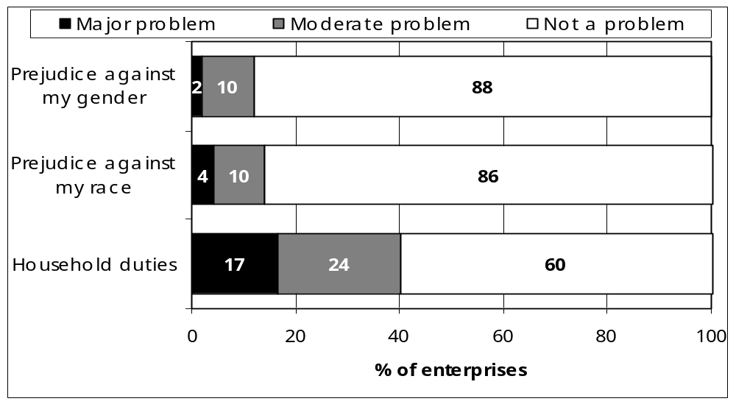

Interviewees were asked what they thought the main problems business women experienced due to their gender. Findings are reflected in Table 4 below. More than half of respondents said that there were no particular problems women experienced.

Table 4: Problems faced by women in business
Problem | Frequency | % of Cases
No problem at all | 288 | 56.8
Household/family duties are very time consuming | 120 | 23.7
Lack of safety from assault in your business area | 119 | 23.5
Pressure from spouse | 70 | 13.8
Discrimination against women by banks when applying for loans | 48 | 9.5
Difficulty finding a replacement during maternity | 42 | 8.3
Other problems | 31 | 6.1

4.2 Previous work experience
Previous work experience of respondents was explored in the question on their occupation immediately before they had started or taken over their current business. The results are reflected in Figure 2 below. In almost half of cases the primary operator of the enterprise had been previously unemployed. In just over a fifth of cases the interviewee was employed in a formal enterprise, indicating the extent to which those who had been retrenched proceed to establish businesses in the informal economy. Only 6.3% of those who were previously employed in the formal economy were doing the same activity as they are doing now. This indicates that skills learned in the formal economy are not necessarily being used in the informal economy. Only a small proportion of the sample was previously employed in another informal enterprise.
Figure 2: Previous work
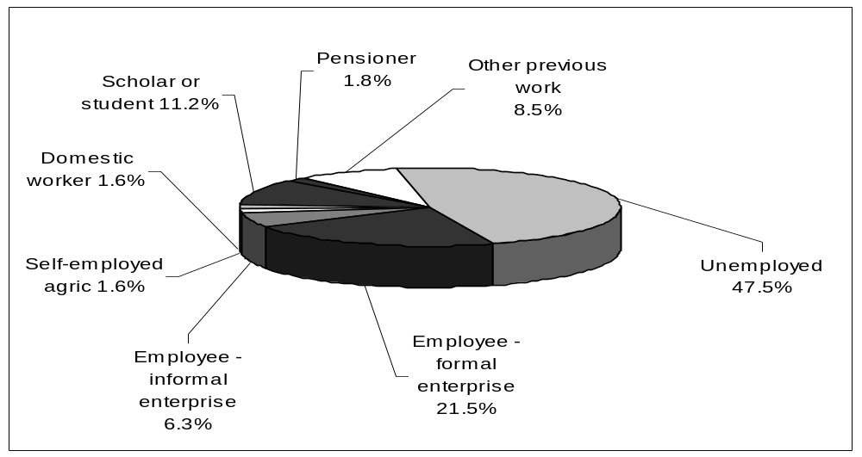

Interviewees were asked if this was their only work. In over four fifths of cases the current activity was their only work, with only 13% of respondents saying they did other work. Nearly 40% of those who did other work had another informal business. Most of those who had other work did not specify what this work was. These findings indicate that there are not as many cases of multiple jobs as would be found in other developing country contexts.

4.3 Motivation for starting the business
It is clear that long term unemployment is a major driver in the establishment of informal enterprises, with nearly 200 interviewees identifying being unemployed for more than six months as the most important reason for establishing their business. Only a very small number of interviewees – 15 cases – identified being laid off in the past six months as a reason for establishing the business. This indicates that the transition between formal and informal employment may take a period of time. A significant number of respondents noted increasing income as a reason for establishing the business. A smaller portion argued that seizing a business opportunity is what motivated them. Over 70 respondents identified working from home – for childcare and other purposes - as a factor.
Figure 3:Motivation for starting this business
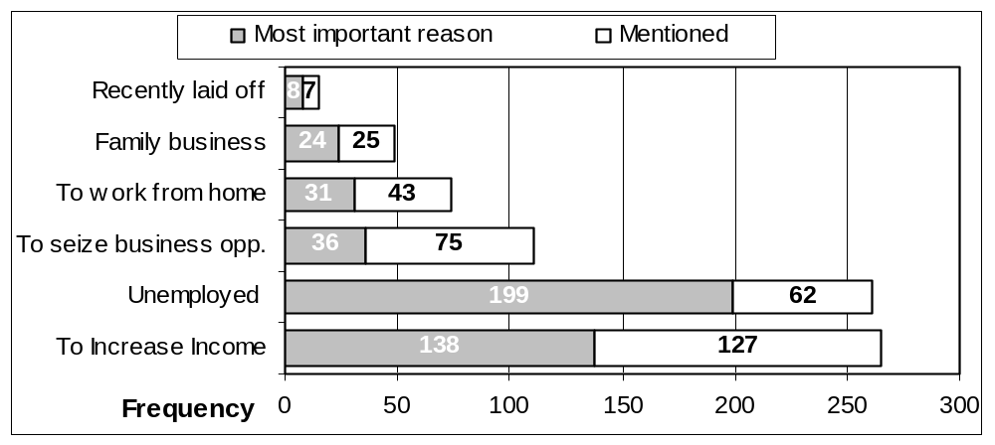

4.4 Household size and income
The number of adults living in one household ranged between one and twelve. On average households had four adults, with a mid point value or median of 3 adults per household. There are between no and 20 children living in the households interviewees belonged to. On average households had three children (the median value is also 3). In just under 40% of cases the interviewee was the only income earner in the household. In 45% of cases there was just one other income earner in the household. Although there are clearly exceptions, generally those working in the informal economy in Durban seem to have large numbers of people dependent on their income.

Questions were asked about the total monthly income in the household. This is an invasive question respondents might be reluctant to answer. They may have an incentive to under or over report or simply not know. This data must thus be treated with caution. The average total monthly income in households was reported to be R3228,41, with a median of R2000. Figure 4 below represents the total monthly household income. A very small proportion of households were earning over R10 000 a month. Just over one in ten respondents reported living in households with an income of between R5 001 and R10 000. Nearly a third of respondents reported to be in middle to low-income households living on between R2001 and R5000 a month. The household subsistence level for Durban for September 2001 was R1914.47 (Potgieter, 2002:61). Over half of respondents reported living in households where the income is just on or (in many cases substantially) below this level. One in four respondents reported living in very poor households – living in households whose total monthly income is between zero and R1000.

Figure 4: Total monthly income of household, n=475

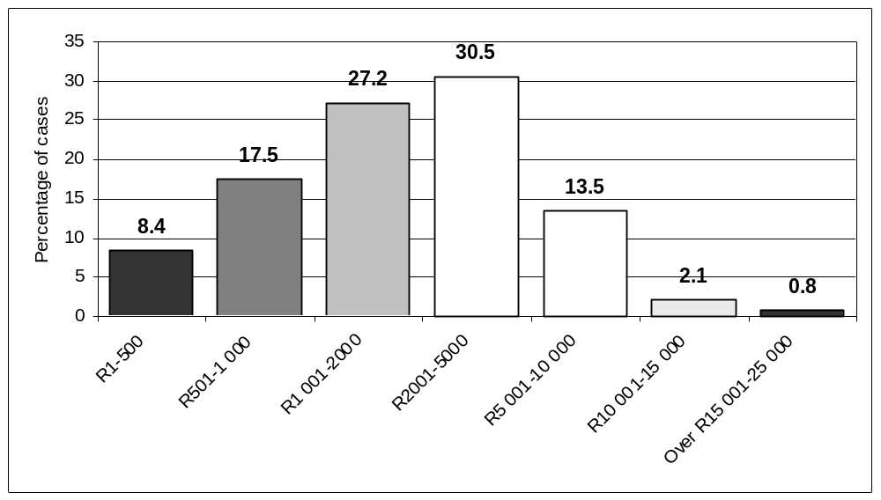

Table 5 below reflects the sector in which those who reported living in a household where the total income was less than R1900 a month was working. It is clear that those working in craft and traditional medicine are particularly likely to be living in very poor households. Those working as childminders, in construction or metal work are less likely to be living in very poor households. Further women are more likely to be living in households whose income is less than the household subsistence level. Over 50% of women interviewees in contrast to 32% of men interviewees reported total monthly household income of less than R1900

Table 5: Those reporting total monthly income of < R1900 a month by sector
Sector | Frequency | % in sector
Craft | 60 | 75.0%
Traditional medicine | 48 | 60.0%
Shebeens | 16 | 39.0%
Hairdressing | 14 | 34.1%
Apparel | 26 | 31.7%
Spaza shops | 18 | 29.0%
Créches | 10 | 25.6%
Construction | 9 | 23.1%
Metal work | 9 | 20.9%
Total | 210 | -

4.5 Use of profits
Respondents were asked how they used their business profits and Figure 5 below shows the majority of business profits were spent on family needs. Respondents were also asked how much their business contributed to total monthly income. The average amount was R1274.32 a month, with a median of R800. Although informal enterprise owners are spending a proportion of their profits on themselves this is not the most important use of profits. It is encouraging to see that some informal enterprise owners were able to save both for business and personal purposes. The literature on supporting informal enterprises is placing increasing emphasis on the importance of saving (see for example Morduch, 2000).
Figure 5: Use of business profits
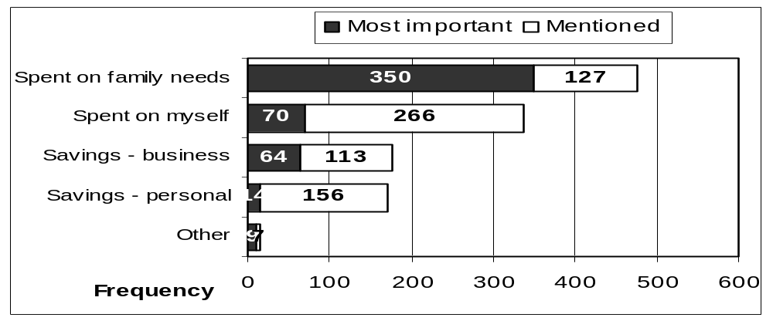

4.6 Organisational membership
More than a third of respondents said that they were a member of some organisation. Figure 6 shows the types of organisations that respondents belong to. Women respondents were more likely to be members of an organisation than men – two thirds of those who responded positively were women.
Figure 6: Organisational membership, n=267
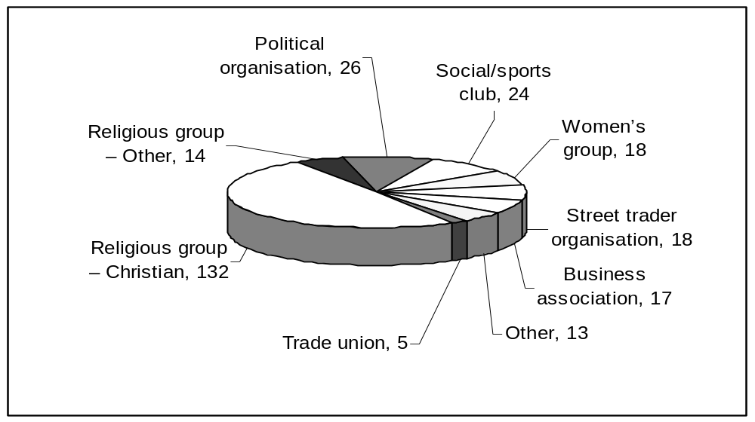

Respondents were then asked if their businesses benefited from their being a member of an organisation. Half of those belonging to organisations felt that their business benefited and half did not. The results by type of organisation are reflected in the table below.

Table 6: Does being part of an organisation help business activities?
 | Yes | No | No. of cases
Street trader organisation | 72.2% | 27.8% | 18
Women’s group | 66.7% | 33.3% | 18
Political organisation | 65.4% | 34.6% | 26
Social/sports club | 58.3% | 41.7% | 24
Other | 53.8% | 46.2% | 13
Business association | 52.9% | 47.1% | 17
Religious group – Christian | 42.4% | 57.6% | 132
Religious group – Other | 28.6% | 71.4% | 14
Trade union | 0.0% | 100.0% | 5

Although in most cases the sample size is too small for statistically significant results, the results do suggest that street trader organisations, women’s groups, political organisations and social clubs and even churches play a useful role in business development.

Unfortunately the question detailing how businesses benefit was badly answered. Only 30 of those who had identified that their membership of organisations benefited identified the nature of the benefits. Those who did identified getting supplies (10), getting legal advice (8), help with management, administration or bookkeeping (4), obtaining credit (1) and other business benefits (7).

5. Characteristics of the Informal Enterprise

5.1 Age of enterprise
As Chandra et al (2001: 17) point out, time in operation is an important marker of an informal enterprise’s market experience and its survival capabilities. Figure 7 reflects the reported year of establishment. Apartheid business legislation, although relaxed in the latter part of the 1980s, was very restrictive with respect to any race group except whites establishing businesses. It is noteworthy that only 26.4% of these informal businesses were established before 1990. There seems to be a burgeoning of activities from 1994 onwards. It is noteworthy that a high proportion – 37.3% – of businesses were established in the three years prior to the interviews being conducted.
Figure 7: The year the business was started, n=504
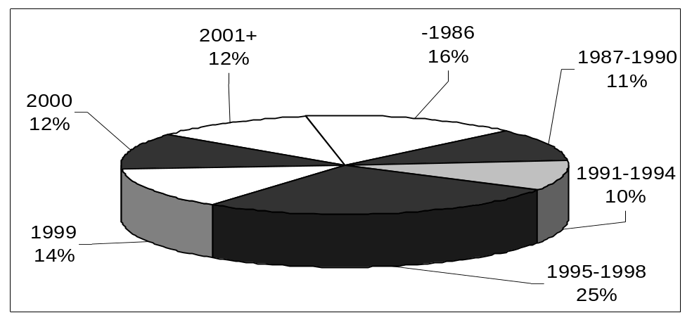

Respondents were also asked how long they had been involved in this business. Nearly 40% of interviewees had only been involved for up to five years. There is a group of more established entrepreneurs who had been involved in this business for over 10 years.
Table 7: Number of years involved in this business, n=504
 | Frequency | Percent
0 -1 years | 56 | 11.1%
2 years | 51 | 10.1%
3 years | 44 | 8.7%
4 years | 47 | 9.3%
5 -10 years | 134 | 26.6%
< 10 years | 172 | 34.1%

5.2 Business performance since inception
As far as business performance is concerned Durban’s informal economy appears to be less vibrant than would be hoped. In Durban only 40% of respondents reported that since inception their business had expanded, while 46% said it had remained the same and 14% that it had contracted. In Johannesburg in contrast since inception, informal enterprise owners reported that business has expanded in 62 percent of the informal enterprises, remained constant in 32 percent and contracted in 6 percent of cases (Chandra and Rajaratnam, 2001:59).

Figure 8 below reflects business performance by sector. Patterns of growth / contraction are not conclusive by sector. Consider, for example, child minders – there were more than average reports of business expansion as well as more than average reports of business contraction. Those working in crèches, apparel, metal work and hairdressing are more likely to report business expansion. In contrast those working in construction, spaza shops, craft, traditional medicine and shebeens are more likely to report that their business has remained the same or experienced negative growth.
Figure 8:Enterprises performance
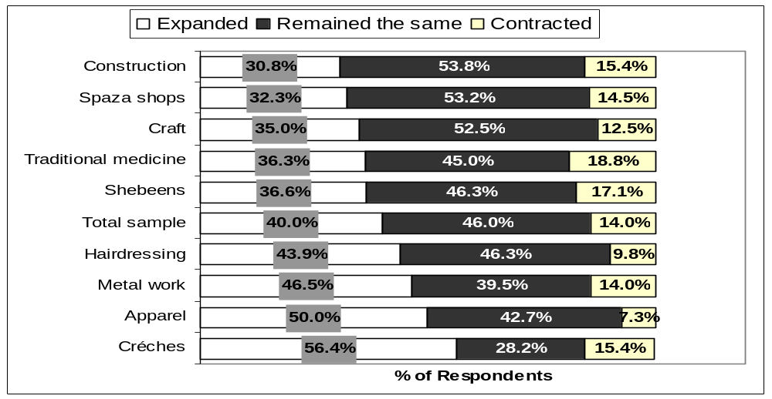

5.3 Fixed capital assets
Fixed capital assets not only reflect the size of the enterprise but may be significant with respect to access to services that facilitate growth, like credit. Respondents were asked how much they would receive if they sold all the business machinery, equipment (including vehicles) and their business premises (excluding the house they live in) at the end of 2001. The response to this question is reflected in Figure 9. It is clear that few informal enterprises have any valuable assets. Over two thirds of respondents had assets that they value equal to, or below, R10 000. There is however a group of more established, ‘better off’ informal enterprises who value their business assets over R10 000.

Figure 9: Value of assets, n=445
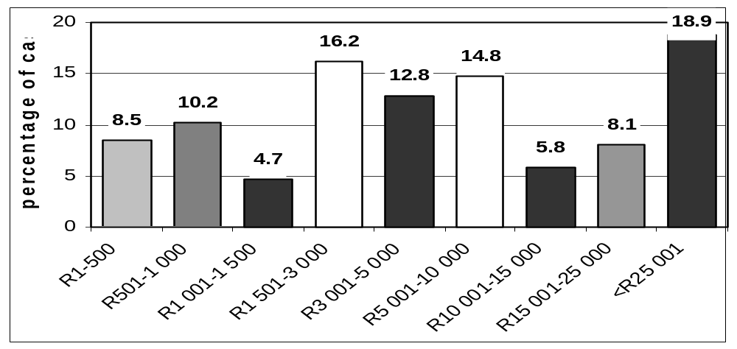
As would be expected there are significant sectoral differences. Over 90% of those operating in craft sector and over 70% of those operating in the traditional medicine and hairdressing sector had assets they valued as being equal to or below R5 000. Two thirds of those working in the metal industry, 60% of spaza shop owners and 51% of shebeen owners valued their assets at over R10 000. The estimated value of assets among enterprises in the apparel sector and crèches were more evenly spread. There is also a gender difference. Those enterprises that had assets valued at equal to or greater than R10 000 are likely to be men. Sixty-two percent of those enterprises in this position are owned by men. Given that there are more men than women represented in this sample the weighted proportion would be even higher.

5.4 Employment created
Over half of the enterprise owners interviewed - 54.6% - had people working with them. The table below shows that there were significant sectoral differences. Those working in metal work, crèches, construction, shebeens and spaza shops were likely to be employers. Those working as hairdressers, in craft, traditional medicine and apparel were more likely to be self employed.
Table 8: Percentage of respondents who had people working for them, by sector
Sector | % in sector
Hairdressers | 26.8%
Craft | 27.5%
Traditional medicine/muthi | 38.8%
Apparel | 42.7%
Spaza shops | 74.2%
Shebeens | 75.6%
Construction | 79.5%
Créches | 82.1%
Metal work | 88.4%

Of those who did have people working with them, in the majority of cases – 46.5% - they only had one employee. In 29%, 12.4% and 5% of cases informal enterprises were employing 3, 4 and more than five people respectively.

The interview schedule made a number of distinctions between different types of employment. Responses are reflected in Table 9 below.
Table 9: Workers, by race, gender and nature of contract
 | Black Male | Black  Female | Colour-ed Male | Colour-ed Female | Indian Male | Indian Female | Total
Full time employee | 159 | 157 | 1 | 1 | 1 | 2 | 321
Part time employee | 99 | 29 | 10 | 0 | 0 | 0 | 138
Unpaid family member | 44 | 67 | 1 | 0 | 9 | 5 | 126
Hired family member | 3 | 4 | 0 | 0 | 0 | 0 | 7
Other hired employee | 6 | 8 | 0 | 0 | 0 | 0 | 14
Total | 311 | 265 | 12 | 1 | 10 | 7 | 606

Most full time employees were black with an even split between men and women. Part time employees were more likely to be men. One in every five employees was part time. There is also a lot of unpaid work with one in every five workers in informal enterprises being unpaid family members. No enterprise owner reported employing foreign or local migrants or white South Africans.

To assess changes in employment trends over time respondents were asked how many employees they had had a year ago and two years ago. Findings are reflected in Figure 10 below. Although there is a slight increase from 2000 to 2001, there is a decrease from 2001 to 2002 particularly with respect to part time employees.

Figure 10: Changes in employment numbers over time
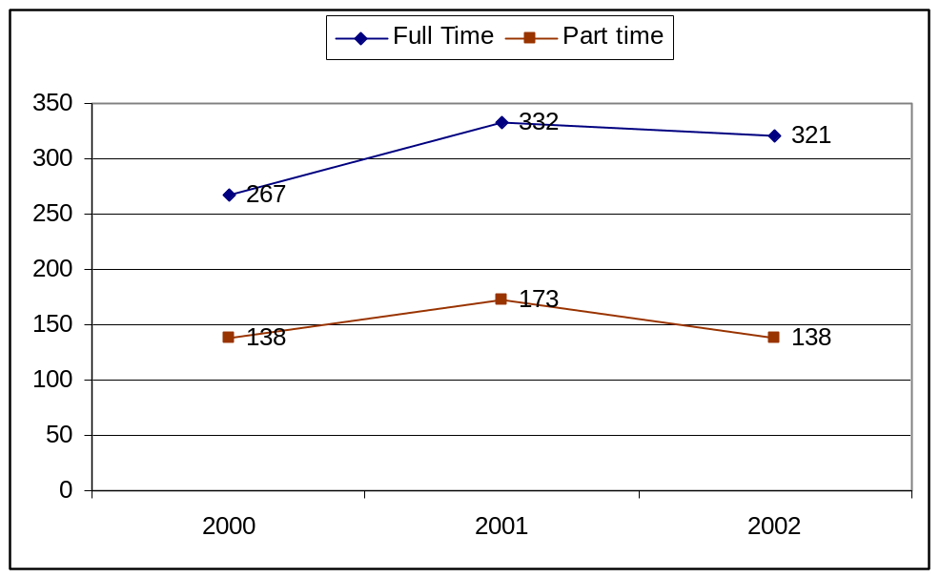

5.5 Employee working conditions and wages
From the results of the question on benefits offered to their workers it is clear that employees of informal enterprises were operating under harsh conditions. Of the 282 people who reported more than 1 person working in the enterprise, 88% reported that they granted their workers no benefits. Table 10 below reflects the findings of those who did report offering benefits. From this it is clear that few were offered sick leave or holiday leave. Even fewer had access to maternity leave or retrenchment cover.
Table 10: Worker benefits
Benefits | Frequency | % of those who work with more than 1 person
Leave for holidays | 20 | 7.1%
Paid sick leave | 16 | 5.7%
Leave for long term sickness | 3 | 1.1%
Maternity leave | 4 | 1.4%
Some form of payment when retrenched | 4 | 1.4%

Enterprise owners were asked what the average weekly wage was. This question was badly answered. Of the 282 who reported that there was more than one person working in the enterprise, only 100 responded to this question. Those who did respond might be the ones paying better wages, as they would be more willing to report. Figure 11 reflects the data that is available and indicates that the majority of employees were being paid less than R200 a week and a further third earn between R200 and R399.

Figure 11: Weekly wage, n=100
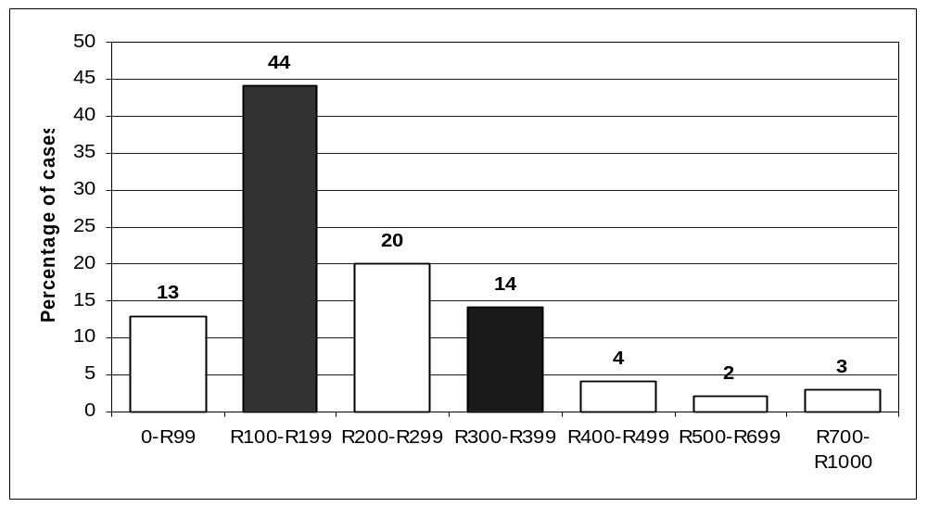

A weakness of the research process was that no interviews were conducted with employees themselves, so there was no opportunity to verify these claims. Even from enterprise owners responses it is clear that workers were operating under fairly harsh conditions.

5.6 Monthly profit
Measuring the profit of informal enterprises is notoriously difficult. Given that few records are kept, most enterprise owners are unable to provide this information. Earnings data should thus be treated with caution. In this questionnaire respondents were asked to give approximate figures for gross earnings as well as figures for their approximate wage and total input / supply costs. From these three figures it was possible to make an estimate for profit. The findings are presented in Figure 12 below. From this it is clear that in some cases informal enterprises are earning nothing or in fact making a loss. Six in ten informal enterprises reported earning R1000 or less. There is then a slightly better off group who earns between R1000 and R3000. Very few business owners reported earning more than R5 000 a month.

Figure 12: Monthly Profit
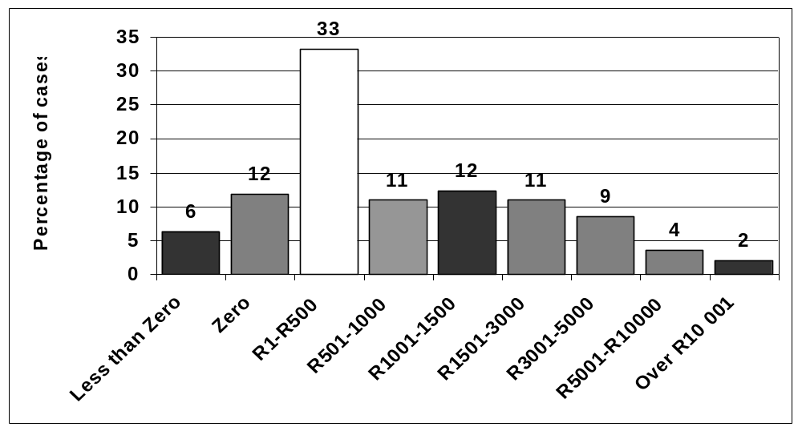

The sectoral trends in profit are portrayed in Figure 13 below. Although there are exceptions there are some broad sectoral trends. Eighty one percent of crafters; 72% of those working in traditional medicine; 70% of hairdressers; 69% of crèche owners and 63% of those working in apparel were calculated to earn below R1000 a month. At the better off end 53% of those working in shebeens; 54% of those in construction; 56% of those in spaza shops and 61% of those in metal are earning over R1000 a month.
Figure 13: Monthly profit by sector, sectoral percentages
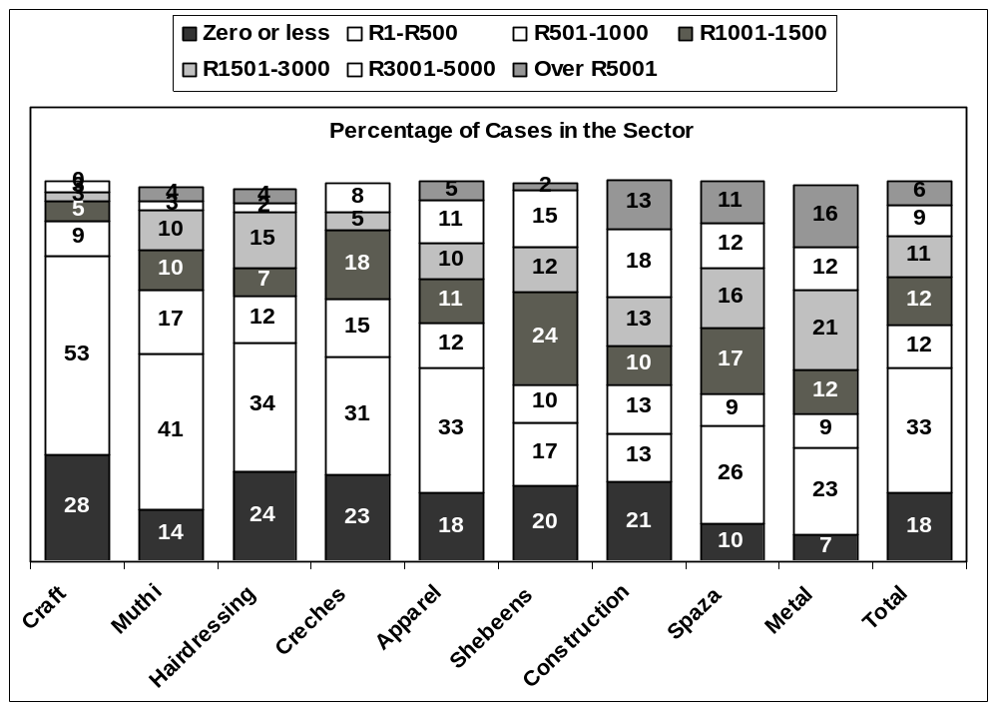

5.7 General business problems experienced
Figure 14 reflects general problems respondents experienced. It is clear that a number of respondents felt their businesses were not as profitable as they would have liked them to be. Low profits were reported by nearly six in every ten respondents as a major problem and insufficient sales / income reported by nearly five in every ten respondents. Variations in income or sales were less of a problem. Those working in the informal economy are often identified as servicing oversaturated markets confirmed by the fact that over 50% of respondents identified too many competitors.
Figure 14: General business problems experienced
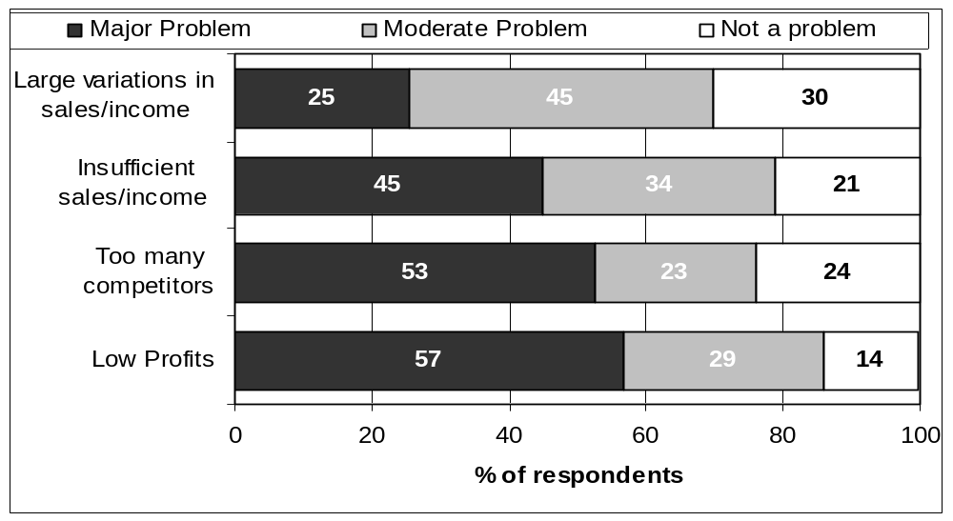

6. Business Environment and Relationship with the State

6.1 Location
Location can be a critical path to or constraint on growth. From the perspective of the City Council there is an ongoing debate about the usefulness of facilities like municipal markets and business hives. In the survey interviewees were asked not only where they are presently located but what their preferred location would be. The findings from this question are presented in the Figure 15 below.
Figure 15: Business location, current and preferred
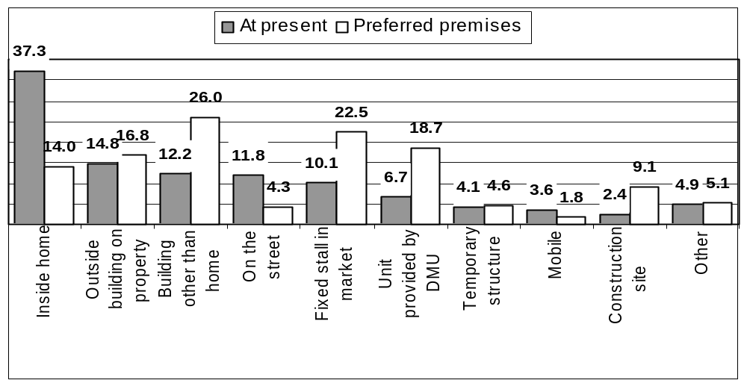

In terms of present location (represented in the shaded areas in the above graph) it is clear that over half of those interviewed (52.1%) worked from home – either inside their home (37.3%) or in an outside building on the same property (14.8%). Not surprisingly over 60% of those who were working from home are women. Just over a tenth of enterprises are operating from a building other than their home, on the street or in a fixed stall in a market. Some interviewees (6.7%) had access to facilities provided by the municipality. In the 34 cases where enterprises where located in these facilities most of them were working in apparel, craft and traditional medicine.

In terms of preferred location (represented by the striped areas in the above graph) a significant portion of people who are currently working from inside their home as well as those operating on the streets would prefer alternative locations. What is also clear from the figure is that there is a call for buildings other than the home, market facilities and units provided by the municipality. Those working in craft and muthi are particularly calling for fixed stalls in markets while those working in apparel, metal work, traditional medicine and craft for facilities provided by the municipality.

Interviewees were also asked why they chose the location they were currently in. Over 40% of respondents noted that there was no other space available reinforcing that there is a need for alternative facilities. Over 40% said they could not afford other space. If the council provides spaces it is thus clear that if they charged market related prices this is likely to exclude a number of those working in the informal economy. Forty three percent of enterprise owners however chose their current location for business related reasons specifically due to access to customers. Just under a quarter of respondents said they choose their present location as it meant that they could combine business with household or family duties. All of those who noted this were working from home - 26.2% of these respondents were men. Finally only an extremely small number of respondents - 2.2% - said that they wanted to escape inspection / regulations.

6.2 Access to basic services
Responses to the question as to whether their businesses had access to range of different facilities / infrastructure are represented below.
Figure 16: Access to infrastructure / facilities
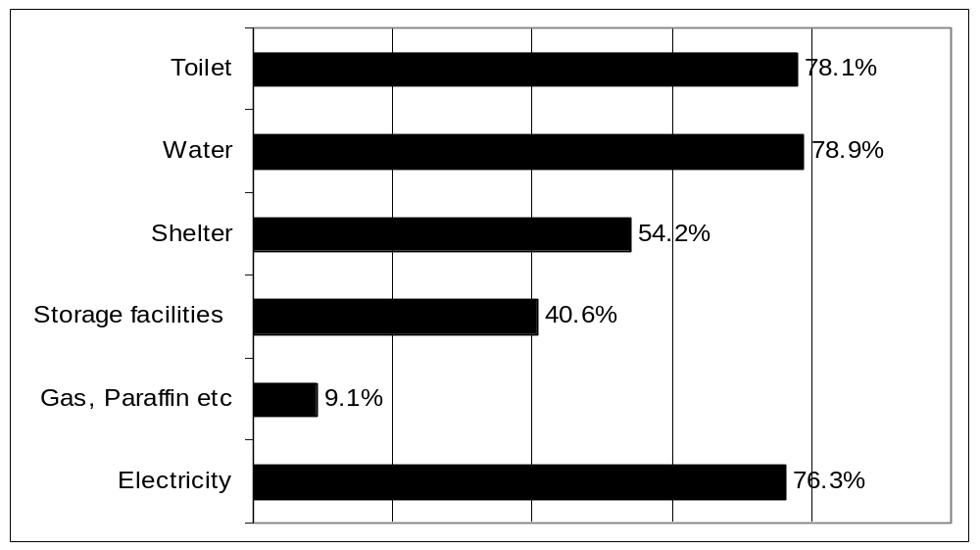

Over 20% of respondents reported that they did not have access to toilet or water facilities at their workplace. Although there are a few cases in each sector of informal operators having access to neither of these essential facilities, this appears to be a particular problem for those working in craft, with just over 60% of respondents reporting that they did not have access to water or toilets. Over 20% of those working with muthi did not have access to water and 17.5% reported not having access to toilets. Further a number of operators across all sectors reported not having shelter. For certain sectors, like construction this is not to be expected. However 55% of crafters and metal workers and over 40% of those working in shebeens, muthi, crèches and apparel do not have shelter. Only 40.6% of respondents reported having access to storage. Storage facilities are likely to be more important for some informal operators than others. In terms of energy usage however it is clear that there are many more people making use of electricity more potentially dangerous energy sources like paraffin and gas.

Later on in the questionnaire respondents were asked directly if access to infrastructure (electricity, water, telephone) and cost of this service were a problem.

Figure 17: Problems with access to basic infrastructure
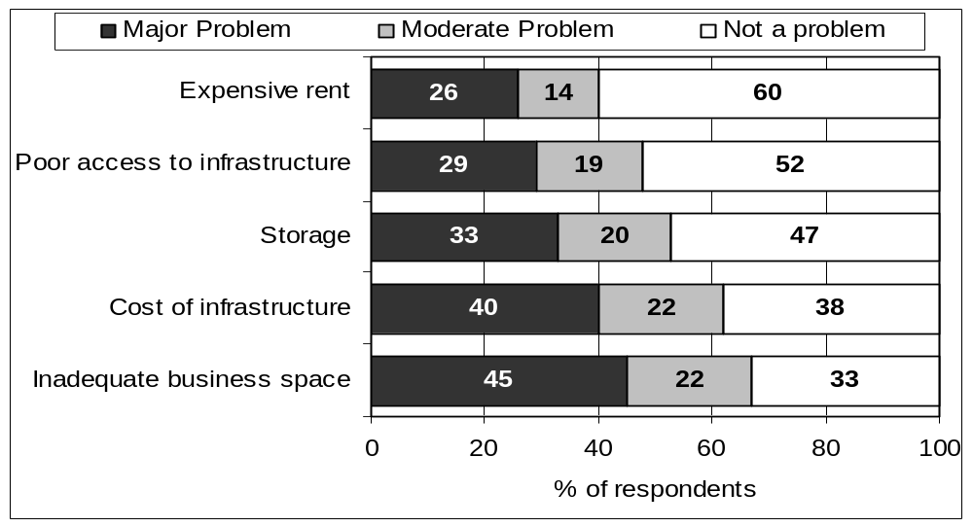

The figure indicates that access seems to be less of a problem than cost. A relatively high proportion of respondents identified inadequate business space as a problem. Those working in craft, metal work, traditional medicine and apparel appear to be in particular need of business premises. In these four sectors there were significantly above average reports of inadequate access to business space being a problem. This indicates the importance of providing appropriately designed incubator spaces in areas near where people are currently working. The opposite holds true in the case of shebeens, spaza shops, crèches and hairdressing salons where there were higher than average reports of access to business space not being a problem. These are the kinds of activities that lend themselves more favourably to operating out of people’s homes.

6.3 Access to transport
Detailed questions were asked about the types of transport used by enterprise owners and their workers, and what they use for transporting their supplies and goods. Taxis are an important mode of transport with over 40% of respondents identifying taxis as their most important means of transporting themselves as well as their goods. Only 26.2% of the sample had access to their own transport. Where this was the case it was reported to be the most important mode of transport for both goods and people. A number of business operators (17.6%) and their workers (19.1%) were walking to work. Only a small proportion of respondents reported using municipal transport. Just over 10% of respondents reported that buses were most important means of transporting goods while less than 6% of respondents reported using trains.

When probed further about problems related to transport, as is clear from Figure 18 below, very few respondents reported that access to public transport was a problem. Clearly cost of public transport is regarded to be slightly more of an issue. The main issue highlighted however is lack of own transport.
Figure 18: Transport-related problems
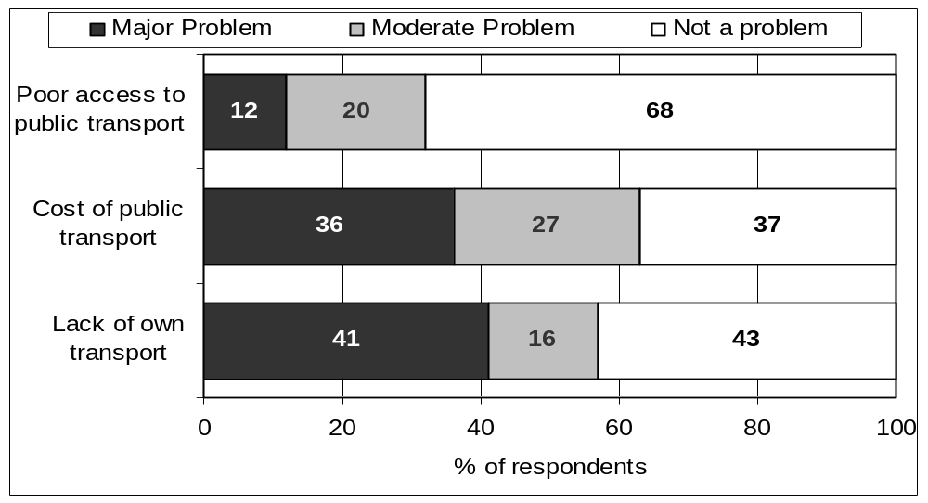

Access to communication technology
Access to communication technology is critical for the day to day running of a modern business, particularly to order inputs, to establish pricing options and to be in communication with customers. It can also be an important tool in terms of business strategy for accessing opportunities and conducting market analyses. A high proportion of respondents – 60.9% – had access to phones, either Telkom or cellular lines. This is substantially higher than was reported in the Johannesburg survey where just over 40% of respondents said they had access to telephones of any sort. Given that the field work for the Johannesburg study was conducted three years before the Durban study, this difference is likely to partly be attributed to increased use of cell phones in South Africa over the past few years. The high degree of access to telephones is an important factor to bear in mind when designing support interventions. Just over 30% of enterprises reported having post boxes. There however appears to be little penetration of more sophisticated communication technology into this part of the economy – only 0.4 and 1.2% of respondents reported having access to the internet and fax machines respectively.

Safety and security
Crime is frequently reported as a major constraint to economic growth in South Africa. Interestingly it appears as if crime was not as big an issue in the informal economy in Durban as it was in the formal economy or the informal economy in Johannesburg. Sixteen percent of informal enterprise owners reported that their business was the victim of crime in 2001. In the survey of formal small medium and micro enterprises, 47% reported being victims in 2001 (Kesper, 2003:53). In the Johannesburg survey of informal enterprises 30% of reported being victims of crime.

The types of crime experienced are represented in Figure 19. The majority of reported cases are break-ins and property theft. Spaza shops and those working in apparel, metal work and shebeens were more subject to being victims of crime than those operating in other activities.
Figure 19: Types of crime experienced in 2001
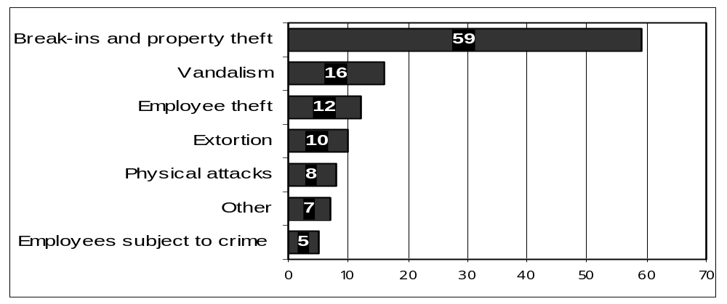

When identifying the types of business problems respondents experience just under 20% of respondents identified theft and safety both for themselves and their workers as a major problem. Fifty nine percent of those identifying either of these to be a major problem were women. This was clearly more of an issue for those working in certain sectors. Just under 50% of respondents who worked in metal work, just under 40% of those working in shebeens and craft and 34% of those working in spaza shops identified crime as a major problem.

6.6 Registration and licences
Only a very small percentage of enterprises (7.7%) had attempted to register as a formal business. In some of these cases the application was still being processed. Of those who had tried and failed the following reasons, among others, were cited – lack of money, the business did not meet the requirements and the council did not permit selling in the area.

Later on in the questionnaire respondents were asked if obtaining a business licence was a problem. Nineteen percent and 24% of respondents reported not being able to obtain a licence as a major problem or moderate problem respectively. This was clearly more of an issue for certain sectors than others. Thirty six percent of enterprise owners working in the liquor trade, 30.2% of those in metal work, 25.6% of those in construction and 22% of those in apparel identified obtaining a licence as a major problem.

6.7 Treatment by local authorities
Enterprise owners were also asked whether treatment by the local authority was a problem. Fifteen percent of respondents felt that this was a major problem. Again, as is clear from Table 11, local authorities are more of a concern for those operating in some sectors than others. The two sectors that are potentially more hazardous to public health are shebeens and informal metal workers. The latter is a concern due to the chemicals used. Enterprise owners are more likely to have had contact with city health officials than others.
Table 11: Treatment by local authority considered a major problem by sector, n=74
Sector | Frequency | % of Responses in sector
Metal work | 13 | 30.2%
Shebeens | 12 | 29.3%
Spaza shops | 9 | 14.5%
Construction | 5 | 12.8%
Créches | 5 | 12.8%
Craft | 9 | 11.3%
Traditional medicine | 9 | 11.3%
Apparel | 8 | 9.8%
Hairdressing | 4 | 9.8%

7. Production and Business Management

7.1 Relations with suppliers
As Durban’s informal economy policy points out the success of the formal and informal economies are linked. The findings for the source of supplies or raw material are reflected in the Figure 20 below. The most frequently cited source was medium to large enterprises, with six in every ten enterprise owners identifying this as a source. This indicates the strength of the forward linkages into the formal economy. The second most cited source was a small enterprise or trader, with over five in every ten respondents identifying this as a source. A portion of these are also likely to be formal. The two more unusual sources of supply were customers and where the goods were obtained for free. As mentioned in the literature, given barriers to entry in other segments of the economy, foreigners are active in the informal economy. One in twenty respondents stated they sourced their goods from a foreigner.

Figure 20: Source of supply, n=503
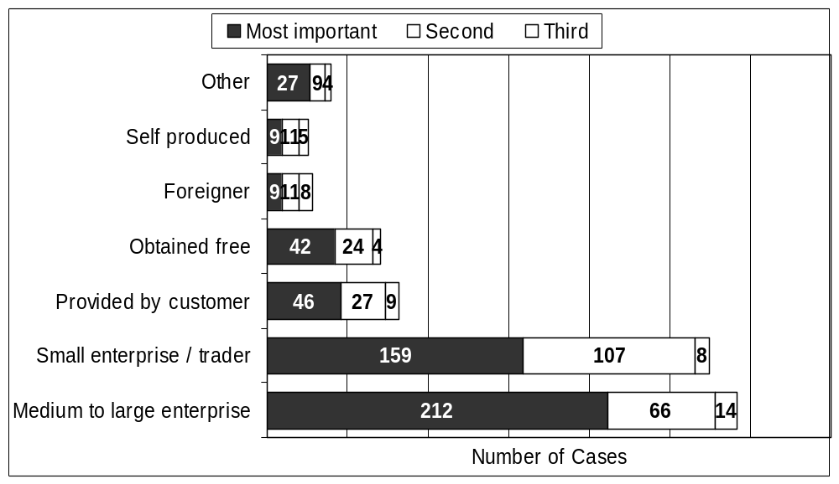

There are obviously key sectoral differences in terms of supply. Table 12 reflects source of supply by sector. It is clear that certain sectors were more strongly linked into the formal economy than others. Apparel, spaza shops, shebeens and crèches tended to source their goods in medium and large shops. These sector supply chains need further investigation. The responses from those working in traditional medicine indicate that a number of formal shops and foreigners were involved in supply. There are also more formal shops involved in supply of crafts than would be expected from a segment of the economy that is often considered to be entirely informal. With respect to apparel, a group of those interviewed are likely to be dressmakers as their supplies were provided by their customers.
Table 12: Source of supply by % in sector, n=503
 | Medium / large shop | Small shop/ trader | Provided by the cust-omer | Foreign-er | Obtain-ed free | Self produc-ed | Other
Apparel | 61% | 70% | 40% | 4% | 1% | 2% | 4%
Craft | 43% | 73% | 1% | 9% | 13% | 5% | 5%
Traditional medicine | 19% | 54% | 0% | 18% | 69% | 15% | 25%
Spaza shops | 79% | 48% | 0% | 0% | 0% | 2% | 2%
Construction | 56% | 41% | 51% | 0% | 5% | 0% | 3%
Metal work | 79% | 37% | 30% | 2% | 0% | 0% | 5%
Shebeens | 85% | 46% | 0% | 0% | 0% | 2% | 0%
Créches | 67% | 36% | 15% | 3% | 5% | 13% | 15%
Hairdressing | 66% | 51% | 22% | 5% | 0% | 0% | 7%
 | 292 | 274 | 82 | 28 | 70 | 25 | 40

Enterprise owners were asked a range of questions related to potential problems they may have with suppliers both of machinery as well as inputs. The findings are presented in Figure 21 below. Most respondents seemed to have fairly good relations with their suppliers and did not feel that there were not enough suppliers. The most significant problem identified was that suppliers were too expensive. In terms of inputs and machinery, lack of tools and machinery was more of a problem than spare parts and repair services. Nearly half of all those interviewed working in the metal work sector and 38.5% and 33.3% of those working in childcare and construction respectively identified lack of tools and machinery as a major problem.
Figure 21: Constraints related to supply of inputs and machinery
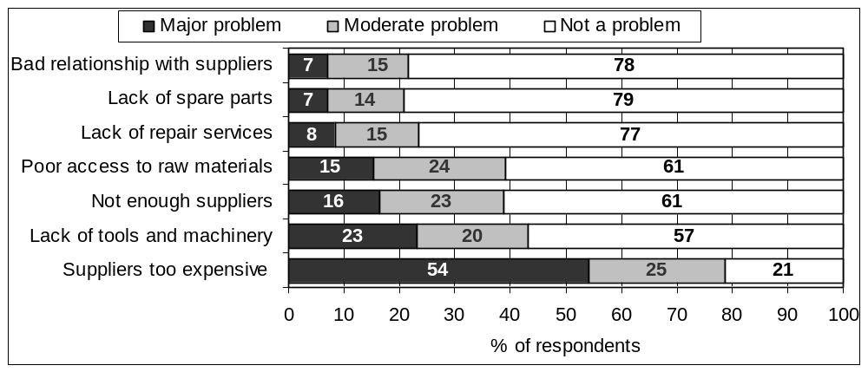

7.2 Relations with customers
The overwhelming majority of respondents - 495 or 98.4 % of those interviewed - sold their goods and services to private individuals or households. The forward linkages into other informal enterprises as well as the formal economy are thus not strong. Only 26 respondents (5.2%) said they sold to other informal enterprises. Only 15 enterprise owners (3%) reported that they sold to formal enterprises and only 11 owners (2.2%) said they sold to middlemen or agents. There also seems to be very little exporting with only 3 respondents saying they sold to foreign businesses. There may be an undercount on this in certain sectors. Research into the pinafore sales in the inner city (Skinner, forthcoming) for example, indicates that a significant proportion of traders purchasing informally manufactured pinafores at the Mansel Road Night Market are cross border traders.

Some of the products / services being offered by the informal businesses like apparel, construction and metal work could benefit from contracts from the state. Although the enterprises fit many of the criteria of affirmable business enterprises they are by definition not registered for VAT purposes. This is a prerequisite for applying for state contracts. Not surprisingly only 4 interviewees (0.8%) reported selling to government agencies or public enterprises. Accessing state contracts is a potential area for expansion for informal enterprises.

Figure 22 reflects problems related to demand for goods and services. From this it is clear that enterprise owners appeared to be fairly confident about what their customers want and were not particularly concerned about customers rejecting their products. Proximity to markets was highlighted as more of a concern. A relatively high proportion of respondents identified poor marketing as a problem. There was also clearly a problem with credit control. Both marketing and credit control skills could be strengthened through a training intervention. The primary problem highlighted in demand for goods and services was that there are too few customers, with 79% of respondents either identifying this as major or moderate problem. This indicates that those working in the informal economy tend to operate in oversaturated markets.
Figure 22: Problems related to demand for goods/services
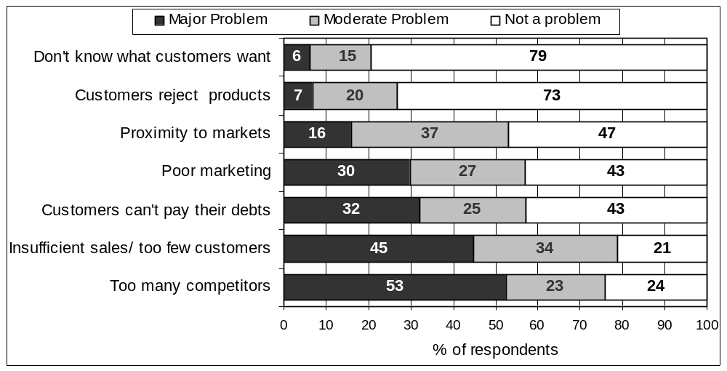

7.3 Business management
Over half of the respondents – 52.5% – did not keep any written records or accounts in order to monitor their business. These respondents were then asked why they did not. The majority of respondents (165) said that they did not think it necessary or important. Fifty one respondents said that they did not how to keep records, while a further 20 said they could not read or write.

Of those who did keep records the types of records kept are listed in Table 13 below. From this it is clear that most of those who are keeping records are recording orders and payments and/or income and expenditure.
Table 13: Nature of records kept
Records / accounts | Frequency | Percentage of responses
Records of orders and payments | 168 | 33.1%
Income and expenditure records | 136 | 26.8%
Records of credit to customers | 123 | 24.3%
Stock control | 28 | 5.5%
Loan repayment | 1 | 0.8%

The rate of general record keeping is very low. Since 57% of enterprise owners identified customers not paying their debts as a major or moderate problem it seems odd that only one respondent reported keeping loan repayment records. This highlights a need for business skills training.

8. Access to Financial Services and Insurance
Financial services and insurance are critical to business growth and security. Access to credit is important to start businesses, to assist with cash flow problems, to diversify and to invest in business assets. Increasing attention in the micro enterprise development literature is being paid to access to savings facilities as well as social protection (Rutherford, 1998, Lund and Srinivas, 2000). The section of questionnaire was expanded to assess current access to savings facilities and insurance.

8.1 Financial Services
Lack of funds / access to credit was the most frequently cited major problem, with nearly six out of every 10 respondents (56.8% of the sample) identifying this. As will be noted later on in this report, this is the priority area that interviewees wanted state-assistance with. This section concentrates on respondents past and present access to financial services.

Start-up funds
Interviewees were asked how much money they had started their businesses with. Findings are reflected in Figure 23 below. Over 50% of respondents started their business with R1000 or less.
Figure 23: Start-up funds, n=450
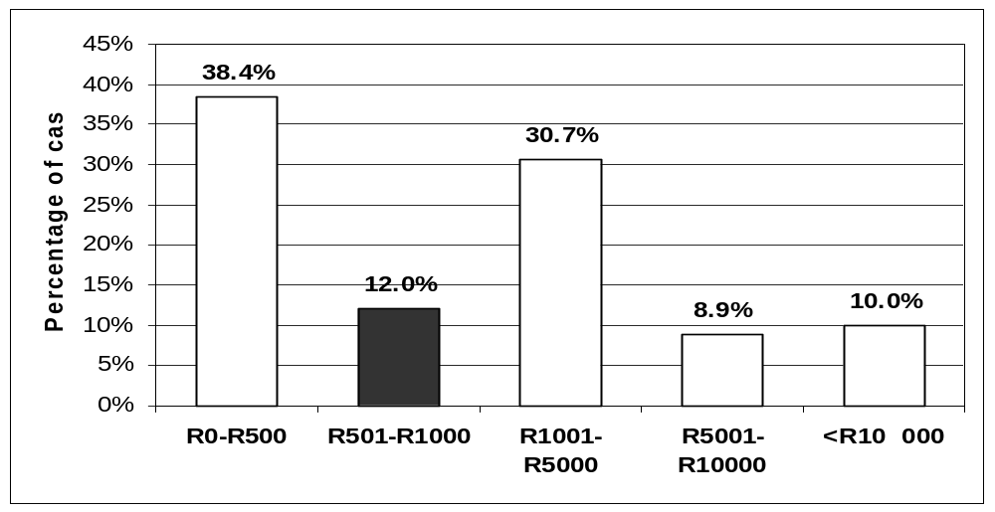

As can be expected there is a significant relationship between the sector the person is operating in and start-up funds they needed. Those working in craft and traditional medicine tended not use more than R1000 to start, while those working in construction, metal work and owners of spaza shops tended to use more than R1000 to establish their business.

Respondents were asked what their main source or sources of start-up funds were. Findings are reflected in Table 14 below. Most respondents relied on their own savings or assistance from relatives or friends. The former indicates the capacity of respondents to save and the latter the importance of family networks to informal work activities. Just over 15% of respondents said they had started with no money either building their business from scratch or they did not need money. Only a small number of respondents reported using retrenchment packages to establish their current business. Given relatively high levels of retrenchment in the formal economy in the Durban area, it is surprising that more people were not using retrenchment packages to start informal businesses. Very few respondents had access to loans from formal financial institutions. Only 10 of those who had received a loan got it from a bank or non governmental organisation. The remaining 7 respondents received their loan from a private money lender.
Table 14: Main source(s) of start up capital, n=641
 | Frequency | % of cases
Own savings | 287 | 56.6
Assistance from relatives or friends | 159 | 31.4
Built the business up from nothing | 46 | 9.1
No money needed | 38 | 7.5
Retrenchment package | 38 | 7.5
Stokvel | 20 | 3.9
Loan | 17 | 3.4
State pension / disability | 11 | 2.2
Other | 25 | 4.9

Access to credit
Only 72 respondents (or 14.2%) had tried to obtain a bank loan for business purposes. Of the 72 respondents who had tried to obtain a loan from a bank only 20 were successful! This means that of the 507 informal businesses operating in the Durban area that were interviewed only 3.9% had ever accessed a loan from the bank for business purposes. This is a significant constraint to business growth.

Business owners were asked why they had not tried to obtain a bank loan or why they thought their loan application had not been successful. Responses are reflected in Table 15 below.
Table 15: Main reason(s) respondent has not tried to obtain a loan or the loan application was unsuccessful
 | Frequency | % of cases
Costs too high | 167 | 34.4
Respondents lacks guarantees required | 129 | 26.5
Procedures are too complicated/respondent does not know how to proceed | 102 | 21.0
Respondent prefers own resources | 102 | 21.0
Banks are not interested in this kind of business | 78 | 16.0
Other sources of credit are more easily accessible | 9 | 1.9
Reason for refusal not explained by the bank | 9 | 1.9
Other | 91 | 18.7
Total | 687 | 141.4

A significant number of respondents (34.4%) identified costs being too high as the main reason they had not tried to obtain a loan or their loan application had failed. Unfortunately no further details were obtain as to what exactly respondents meant by this – was it the loan itself that was too costly (i.e. the interest rate) or the process of trying to obtain the loan? Particularly for self employed entrepreneurs time away from their business is money lost. It is likely to be a combination of both factors. One in four, five and six respondents respectively identified collateral requirements, complicated procedures and banks not being interested in this kind of business, indicating how inaccessible formal loan facilities are to this segment of the economy. This combined with the fact that few respondents said that other sources of credit were more easily accessible highlights that this is a significant problem for those working informally.

Those few respondents who had managed to access the formal financial institutions, were asked which institution they had received a loan from. Five respondents had loans from the KwaZulu-Natal government development corporation’s Bank - Ithala while the rest had received loans from range of commercial banks(15). In terms of collateral of those who were successful only 3 used business assets, while the rest used their house or other assets. One of the disadvantages of not being registered would be not being able to use the business as collateral.

Respondents were also asked if during the past 12 months they had received any loan/credit from any source or bought anything on credit. Only 28 respondents reported receiving credit for business purposes and only 21 for other purposes. Most of those who had received credit had received it from a relative or friend (20) a private money lender (13) or a rotating saving group or stokvel (7). Only 2 respondents reported getting credit from a supplier and no respondents said they had received credit from a government institution. The amounts borrowed tended to be small. Of the 28 respondents who reported how much they had borrowed for business purposes over 80% were R3000 or below. Half of those who had received credit used this for purchasing supplies. Others used it to repay debt (8) improving or replacing premises or machinery (7) or for family emergencies or celebrations (7)

South Africa has a vibrant private money lending industry which is well known for charging extremely high interest rates. Respondents were asked if they in general, used private money lenders. Seventy enterprise owners (13.8%) indicated they did. As noted only 13 respondents said that they had used a private money lender in the last year. Private money lenders often require a pay slip as a condition for accessing loans making them relatively inaccessible to those working in the informal economy. Self consciousness about using money lenders may however led to an underreporting on this form of access to credit.

It is thus clear that informal entrepreneurs in Durban were struggling to access credit or loans for business or other purposes.

Access to savings facilities
Drawing on the experiences of institutions like the Grameen Bank in Bangladesh and the Self Employed Women’s Association’s (SEWA) Bank in India, there is increasing focus on (even the poorest) micro-entrepreneurs’ ability to save. Rutherford (1998:1), for example, highlights the irony of exploiting the entrepreneurs’ ability to save through encouraging them to go into debt. International experience demonstrates that what is needed are institutions that are accessible, friendly and will accept small deposits, in an environment in which clients also have access to other kinds of services (Lund and van der Ruit, 2000).

A surprisingly high proportion of respondents - 57.6% - said they had bank accounts. As would be expected there are differences by sector and gender. Very few people working in craft and traditional medicine had bank accounts whereas over 70% of respondents who own crèches, construction enterprises, spaza shops or shebeens had bank accounts. Two thirds of the men interviewed had bank accounts. In contrast only half of female respondents had accounts.

It is clear from Table 16 that some institutions are more accessible to informal enterprise owners than others. Of the big commercial banks, Standard Bank had a higher number of clients in this segment of the economy than First National Bank or ABSA. Only six respondents out of the 292 people who had bank accounts banked with Nedbank. Notably just over a fifth of respondents held accounts with Ithala indicating that this institution was at the time playing an important role in the banking. More than half of those who were banking with Ithala said that their businesses benefited. This is significantly more than is the case with the commercial banks. The cross tabulation however is not statistically significant as the sample size is too small.
Table 16: Institutions that informal business owners bank with
 | Frequency | Percent
Standard Bank | 78 | 26.7
Ithala Development Finance Corporation | 65 | 22.3
First National Bank | 41 | 14.0
Natal Building Society | 38 | 13.0
ABSA Bank | 31 | 10.6
Peoples Bank | 13 | 4.5
Other | 26 | 8.9
Total | 292 | 100.0

Fewer than 40% of respondents said that having a bank account did benefit their business. Those who noted a benefit said that they used money from the bank to buy raw materials / stock (39) or the money saved by the business was banked (38). Twelve respondents noted that the interest on investment increased profits and a further 12 respondents that the banks were prepared to lend money. A large proportion (33.6%) of those who felt that the account did not benefit their business said that this was because the account was used for personal rather than business matters. Others noted that they did not save any money or that they did not use the bank facilities. From these responses it is difficult to weight whether the facilities being provided by the banks are inappropriate or that the entrepreneurs’ capacity to utilise the services provided is limited.

Those who did not have bank accounts were asked how they saved money. Over 60% of respondents said they did not save any money or they used it all for family purposes. Of the small number that did save money they either kept it at home or saved using stokvels. These people are particularly vulnerable to their money being stolen.

8.2 Insurance
There is increasing interest in social protection for those working in the informal economy (see Lund and Srinivas, 2000). A defining feature of working in the informal economy is the precarious nature of work, with there being little protection in the face of risks. A new section of the questionnaire was introduced to consider social protection related issues, looking at what kind of insurance those working in the informal economy currently have access to and who is providing it.

A surprisingly high proportion - 248 or 48.9% - of respondents recorded having some type of insurance. The types of insurance people had access to are reflected in Table 17.
Table 17: Type of insurance cover
 | Frequency | Percent
Death | 239 | 47.1
Fire damage | 24 | 4.7
Goods lost through theft etc | 23 | 4.5
Health / medical aid | 20 | 3.9
Other | 5 | 1.0

It is clear that those who do have insurance largely have death cover. This is likely to be funeral benefit cover rather than life cover. A tiny number of respondents - 3.9% - had access to cover with respect to ongoing health concerns - medical aid. Respondents were asked if they were sick what usually happened to their business. On the one hand 43.1% of respondents said that they would have to close their business. This indicates a vulnerability to health related problems. Given the high prevalence of HIV/Aids this is likely to be a factor constraining growth in the informal economy. On the other hand 24.8% said their employees would keep it open and 29% said that their friends or relatives would keep it open. The latter particularly indicates that those working in the informal economy are often supported by strong social networks.

Only a very small proportion – just over 10% had business related insurance – protection for fire damage and loss of goods. Eighteen respondents had both insurance against fire damage and loss of goods, so the percentage of informal enterprises that had business related insurance is in fact smaller – 3.6%. Informal enterprises that had either one of these two types of insurance were relatively evenly spread between sectors, with the notable absence of craft and traditional medicine. Given that those operating in the informal economy are particularly subject to shocks this is a serious concern.

Respondents were then asked what type of insurance institution they belonged to. As is clear from Table 18 below only a small proportion of people are being serviced by formal insurance institutions.
Table 18: Type of insurance institution respondent belongs to
 | Frequency | Percent
Burial society | 163 | 32.1
Private insurance company | 79 | 15.6
Community institution | 27 | 5.3
Medical aid scheme | 20 | 3.9
Other | 5 | 1.0

9. Training and Other Support Services
As Liimatainen (2002:4) in her review of the literature on training and skills acquisition in the informal economy points out ‘the development of relevant skills and knowledge is a major instrument for improved productivity, better working conditions and the promotion of decent work in the informal economy’. In this section interviewee’s educational history and particularly their past and present access to business-related training is considered.

9.1 Educational background
As is clear from Figure 24 most respondents had some education with 62% of the sample having high school education. Six percent of those interviewed however had no education and 9.3% had postgraduate education. There are however significant sectoral differences, with a high proportion of craft and muthi enterprises having no education – 22.5% and 13.8% respectively. This indicates the difficulty of providing a training intervention – that there are such divergent levels of skills.

Figure 24: Highest level of education, percentage
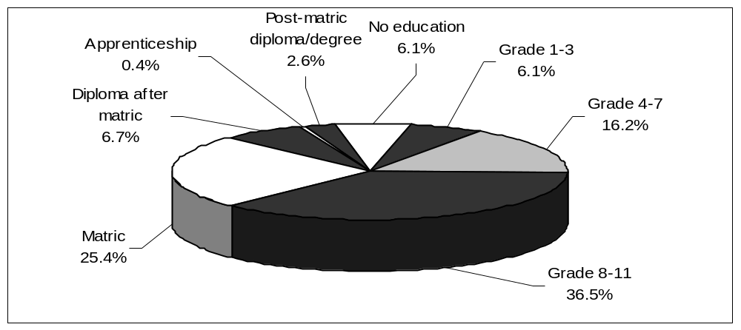

Respondents were asked what vocational training they had.
The overwhelming majority – 67.5% – did not have any vocational training. As is clear from Table 19 below, those who did have vocational training were largely semi-skilled workers. Once again there are sectoral differences. Most of those who have some kind of vocational training were involved in apparel (25.8%), metal work (19.2%) and construction (17.2%). A portion of all of these respondents was likely to be using their skills in their current work.
Table 19: Highest level of vocational training, n=151
 | Frequency | Percent
Semi-skilled worker | 65 | 43.0
Skilled craftsman (technical certificate) | 48 | 31.8
Technician (diploma) | 16 | 10.6
Master craftsman (certificate) | 7 | 4.6
Other level | 15 | 9.9

Enterprise owners were asked how they learned the skills they used in their current business activity. Twenty seven percent of respondents felt that they did not need skills indicating that informal enterprises often devalue what they are currently doing. Thirty five percent of respondents reported that had taught themselves; while 19% had learnt from relatives. A further 11% had learned from school or another training centre. It is thus clear that very few people had been assisted into their current activities through a training intervention.

9.2 Support services accessed
Respondents were asked if they had ever received help through any training or assistance programme. The results are reflected in Table 20.
Table 20: Assistance received by type and service provider, n=88
Assistance provided by: | Gov | Pri. Sector | SETA | NGO | Other | Total
Type of assistance
Training | 13 | 13 | 1 | 15 | 17 | 59
Machinery or equipment | 1 | 2 | 0 | 0 | 2 | 5
Marketing of products | 0 | 3 | 0 | 0 | 2 | 5
Opportunity identification | 0 | 1 | 0 | 1 | 0 | 2
Legal advice | 0 | 0 | 0 | 0 | 1 | 1
Other | 5 | 3 | 1 | 2 | 5 | 16
Total | 19 | 22 | 2 | 18 | 27 | 88

From this it is clear how grossly under-serviced this group is. Eighty eight percent of respondents had never received help through training or any other assistance programme. Of those who had received assistance most of them had attended training. That said the 59 respondents who reported being trained translates into only 11.6% of the total. Further of those who had been trained only 14 reported receiving this from the government and in only one case was a SETA involved. Given that there were only 19 cases cited where government had been involved in providing support, this corroborates previous claims (Skinner, 2000 and Devey, Skinner and Valodia 2003) that the informal economy is not being supported by state small business support and training programmes. It is clear that those working in the informal economy have had little or no success in accessing other forms of assistance.

Respondents were asked if they themselves or their workers were currently receiving training and only 21 (4.1%) said they were. Of the 507 enterprise owners interviewed and the further 617 people working in the enterprises surveyed only 30 were currently being trained. More detailed questions were asked about the type of training the respondent and their workers were receiving. Seventeen of the 30 cases where training was occurring the training was related to child minding. This indicates the relative strength and outreach of the support structures in the educare field. There were one or two cases each of more sector specific training – machinist skills, fashion design, welding, bricklaying/ plastering, hairdressing. There was only one case of business management skills training.

9.3 Demand for training
On specific training needs the type of training needed, 153 respondents (30.6%) said they needed further training and 67 respondents (24.3%) said their workers needed training. Two issues are noteworthy. First, of the 153 who felt that further training was necessary, only 53 specified what training they thought they needed. This question was near the end of the questionnaire and was perhaps subject to interviewee fatigue. Despite this it interesting that 30 of the skills identified were business skills. The skills identified for workers were more sector specific.

Few interviewees considered lack of skilled labour as a major problem (9%) and slightly more considered this a moderate problem (28%). This may be related to high levels of retrenchment in the formal economy leading to an oversupply of skilled labour. Certain skills seem to be in shorter supply than others. 55.8% of those working in metal work and 48.7% of those working in construction and 34.1% both in hairdressing and apparel identified lack of skilled staff as a problem.

9.4 Prioritisation of support services
Figure 25 below reflects problems related to supply of support services. The lack of funds / credit is the primary problem identified. As outlined in section 8.1 of a total of 507 interviewees, only 20 had successfully secured a loan. From this set of questions it is clear that enterprise owners themselves are identifying access to support centres as a problem. This poses a significant challenge to both Khula Finance and Ntsika Enterprise Promotion Agency - the micro-finance and business support services arms of the Department of Trade and Industry.
Figure 25: Problems related to support services
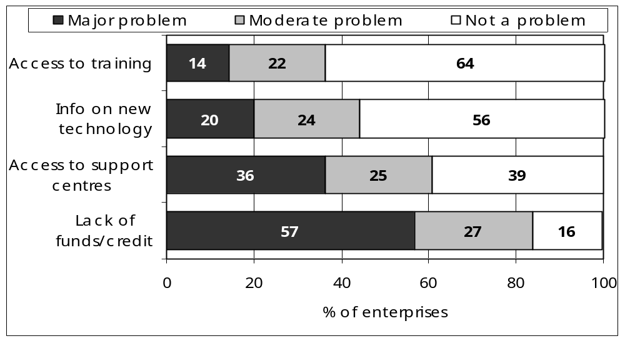

Some enterprise owners were clearly calling for information technology. There is less demand for access to training than might be expected.

Those working in the informal economy arena caution us with respect to the calls for credit. The current co-ordinator of the international alliance of street vendor organisations highlighted this:

Those working in the informal economy often look at their situation and see that profits are low. They therefore conclude that access to money would solve their problems. When their businesses are carefully analysed you often find that access to credit would not necessarily help. In essence needing money is often an expression of another problem. (Skinner, 2000)

More recently Self Employed Women’s Union (SEWU) General Secretary articulated this as follows:

When the business is not growing it’s not that the business needs a loan. It’s like a headache; if you have a headache it doesn’t mean that you need a painkiller. You have to think about all the causes of the headache. (Devenish and Skinner, 2004).

Access to credit is access to debt and, if not well managed, can lead to further hardship. This is not to say that access to loans is not important but it has to be part of a package of support services one component of which should entail debt management training. Informal enterprises need business analysis skills. Qualitative interviews (Cross et al. 2001; Skinner 2000) indicate that a standard set of business skills is unlikely to be as useful as a diverse range of skills. Business skills, covering such issues as financial management, market analysis, buying, costing and customer care would assist informal operators. Further there are a number of life skills such as assertiveness training, negotiation skills, and conflict resolution skills that would assist informal workers, particularly women’s business activities. Further there are industry- specific training interventions.

10. Priority Interventions for Local Government
The household information indicates that support to this segment of the economy could boost income for some of Durban’s poorer households. The enterprise profiles indicate that employment is being generated and profits earned. What the survey results powerfully reveal is that these enterprises are institutionally isolated. Very few have ever obtained a loan from a bank or credit from any other institution; very few enterprise owners or their employees have ever been or were at the time of the interview being trained and few if any have had access to other forms of business support. The private sector, national government and non-governmental agencies have clearly not delivered to this group. If the city is to build on its record of innovative management of the informal economy, the council will have to play a proactive role.

One of the questionnaire’s strengths is the emphasis placed on respondents identifying problems. Figure 26 summarises the issues that a high proportion of respondents identified as a problem. Of the top nine problems listed, all but three – lack of funds / credit, suppliers too expensive and poor marketing - are issues that the council has direct influence over.

Figure 26: Summary of issues identified as major or moderate problems
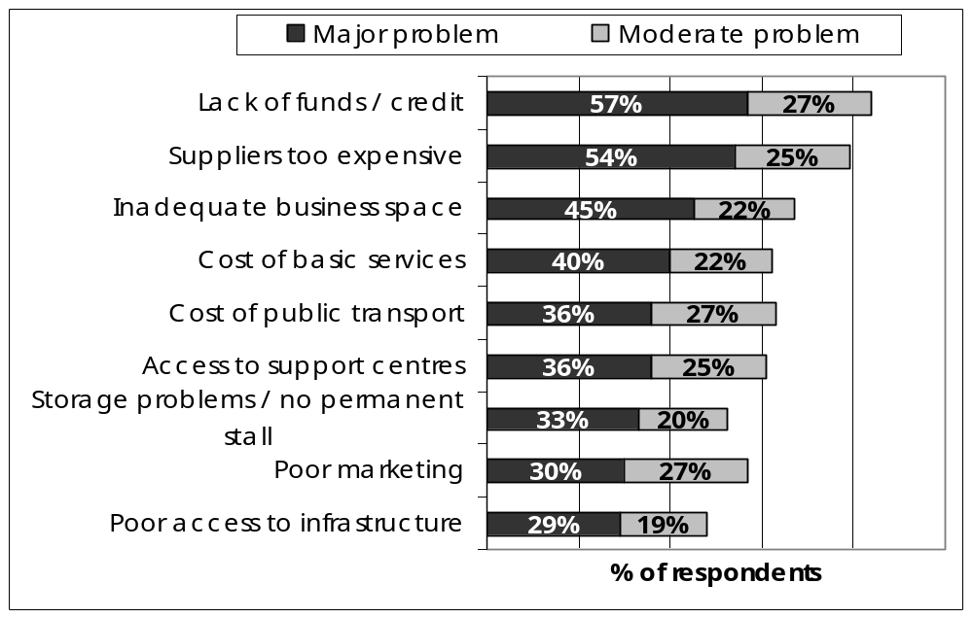

Further, enterprise owners were specifically asked what the most important contributions that they thought local government could make towards promoting the profitability of their business. Findings are presented in Figure 27 below.
Figure 27: Priority interventions for local government
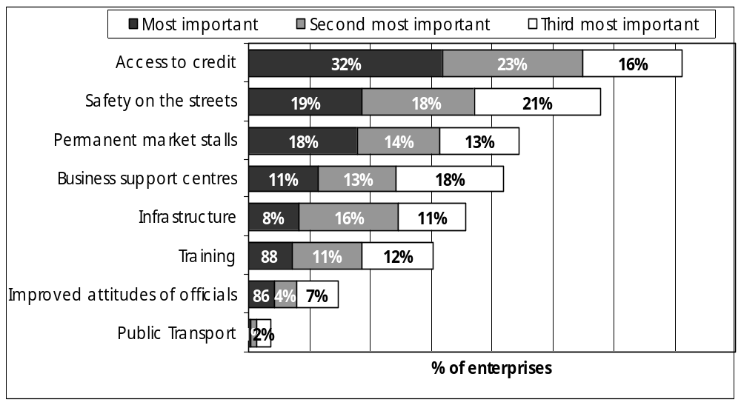

If we combine the information gleaned throughout the questionnaire and the two graphs above, potential areas of local government interventions can be grouped into three broad categories – basic services (policing, water, sanitation, electricity, housing and transport), business infrastructure (business space and storage) and support services – particularly access to credit, business advice and training. Each of these will be considered in turn.

With respect to basic services safety on the streets was identified as an important intervention. Sixteen percent of those enterprises had been victim to criminal activity in the year before the interview. Twenty percent of interviewees reported theft and safety for themselves and their workers as a major problem. Strengthening policing services and particularly awareness raising among the police force about the informal economy is an important area of intervention. Water, sanitation and electricity as well as housing and shelter are critical interventions that support those working in the informal economy. A high proportion of those interviewed were working from their homes. One in five of those interviewed did not have water or toilets at their place of work. Durban has made progress in rolling out these basic services (Todes, 2003), although the challenges remain significant (Charlton, 2003; South African Cities Network, 2004). Further, surprisingly few respondents were making use of public transport. The cost of public transport and poor access to public transport were identified as particular issues. It is critical that those delivering these services are mindful in the design and implementation of service delivery of the overlap between living and working spaces as well as the particular needs of those in the informal economy.

The delivery of these basic services falls outside the ambit of the local government departments that traditionally deal with the informal economy – those managing informal trade, or promoting small business specifically or economic development more generally. The fact that so many enterprise owners are identifying these kinds of issues as problems or potential areas of intervention, points to the importance of an integrated approach to the informal economy. Durban has an informal economy which is experiencing implementation problems. The policy was formulated at a time of institutional restructuring and has not led to the integrated approach envisaged. The Council needs to strategise about how to either engender renewed commitment to this or find an alternative means of securing a concerted approach to guide all council departments whose activities impact on the lives of those working in the informal economy.

With respect to business-related infrastructure, inadequate business space was highlighted by 67% of respondents. As figure 15 on (page 26) indicates, there is a significant difference between where businesses were currently located and where business owners would have preferred them to be located. Clearly some of those working in the informal economy wanted to remain working at home, others however were calling for permanent market stalls or manufacturing units. Those working in craft, metal work, traditional medicine and apparel had a particular problem in this regard. This indicates the importance of providing appropriately designed incubator spaces or permanent trading stalls near where people are currently working. There is a further problem with respect to storage, with more than one in two respondents identifying this as a problem. This kind of business infrastructure clearly needs to be prioritised. Given the household earnings and profit data as well as the reasons cited for current business location, although there may be exceptions, it is unlikely that those in the informal economy could afford market related rates. The Council is thus likely to have to subsidise these spaces.

One of the more remarkable findings from the survey is how few business support services those interviewed had ever accessed. This is an area of intervention that needs to be urgently addressed. The Department of Trade and Industry (DTI) has acknowledged that their small business support policies have been inadequate and are in the process of revamping them (Rogerson, 2004). If services are to be rolled out to those in the informal economy at the scale that is required, the city, in collaboration with the DTI and other role players, has to play a proactive role.

As is clear from Figures 26 and 27 (page 45) there is a strong call for access to credit. Should local government get directly involved in providing micro-finance and/or savings facilities? For one this would be outside of their constitutional responsibility for another sustainable delivery of micro-credit is a highly technical task and for another there are a number of current role players that are better placed to provide these services – private sector, non-governmental agencies and state supported institutions.

Since 2002 when the interviews were conducted there have been positive developments in the financial service sector. Partly in response to the Financial Service Sector Campaign, four of the big commercial banks have introduced banking services for the poor under a product label ‘Mzantsi’. This was launched in late October 2004 and within the first six weeks more than 200 000 people opened Mzantsi accounts (Streetnet Statement,14/12/2004). Although the Mzantsi accounts are likely to be positive for those in the informal economy, it is informative that in this survey although nearly six in every ten respondents had bank accounts, very few felt having these accounts was useful for their business. This suggests that accessing an account is only the first step and that it is critical that banks develop products that are suitable for those working in the informal economy, for example using a savings track record as a basis for access to credit. Further the survey reveals Ithala is playing a role in providing savings and credit facilities for those in the informal economy. Ithala often services areas where commercial banks are not present – particularly rural and former township areas. Ithala’s banking licence still needs to be granted by the National Department of Finance. Local government should play an advocacy role in these processes and keep those working in the informal economy in the city informed about developments.

There are other important role players in the provision of financial services. The DTI’s Khula Enterprise Finance Facility provides wholesale finance to intermediaries that support small businesses. Further research needs to be conducted as to which intermediaries are active in the Durban Metropolitan Area and the obstacles they are experiencing in providing micro-finance to very small businesses. Another institution that has experienced some success in providing loans to those in the informal economy is the Land Bank. Further there are non-governmental organisations that specialise in providing microfinance like the Foundation for International Community Assistance or FINCA. FINCA, an international NGO, established offices in the Durban inner city in the late 1990’s. No respondents reported accessing loans through any of the organisations listed above. Local government needs to establish both what problems these providers and their potential clients are experiencing. One of the problems is likely to be that enterprise owners are not aware that these services are available. Information collation and dissemination about what products there are and how to access them would be an easy role for local government to play.

It has been argued that the call for credit can disguise other problems. Respondents themselves called for small business support services. Business mentoring and analysis are one of the services these centres could provide. Most respondents identified low profits, too many competitors and too few customers to be a problem. Nearly six in every ten respondents self reported poor marketing as a problem. These responses confirm the need for this kind of intervention. Those staffing support centres would need to have both cross cutting knowledge and sectoral knowledge. Time away from work particularly for those who are self-employed is often money lost and respondents have identified problems with the accessibility and cost of transport. To maximise utilisation the city could introduce mobile units. The council already gives substantial resources to the Thekwini Business Development Centre. The task would thus be to extend existing services to the informal economy and also establish new centres.

Some respondents are calling for training. Half of those interviewed did not keep business records and as noted above respondents identified marketing as a problem. Respondents also indicated that they had problems with managing customer credit. There is a need for appropriately designed and delivered basic business skills training. Further there is a need for sector specific skills development. Finally, one quarter of those interviewed had either no education or less than 7 years. Adult basic education and training - literacy, numeracy and business English is likely to strengthen livelihood activities for these people.

There are also problems with respect to supply of training services. There are two potential routes whereby those working in the informal economy can access training – the Sector Education and Training Authorities (SETAs) and the National Skills Fund. As Devey, Skinner and Valodia (2003) outline this system does not adequately service those working in the informal economy. The SETA’s are funded through the skills levy which is paid by employers who are registered - and thus in the formal economy - and whose annual wage bill is more than R250 000. There is evidence that SETAs tend to prioritise the needs of those contributing to the skills levy. The National Skills Fund relies on training providers responding to incentives. Training providers are often reluctant to service those in the informal economy. The reasons include the lack of profitability because workers cannot cover the costs, the low levels of education of workers, the need to develop non-traditional methods, the mobility and thus difficulties of accessing workers, and the fact that many trainers are afraid to enter the areas where people need to be trained (Devey, Skinner and Valodia 2003:159-160). If training is to be provided, local government will have to establish an incentive structure for trainers to ensure they service those in the informal economy.

This report has provided an overview of constraints to growth. The data provides an opportunity to conduct much more detailed sectoral analyses in line with the City’s Informal Economy Policy suggestions. The policy (2000) states that detailed sectoral analyses should be conducted with a view to establishing programmatic interventions and that economically trained sector specialists should be introduced into area based management offices. This data could provide baseline information for such sector specialists.

Figure 26 (page 45) excludes the issues such as profits being low, too few customers and insufficient sales, all of which a large number of enterprise owners reported to be significant problems. This combined with income data demonstrates that a number of these jobs are not very profitable. It is also clear from the interviews that employees were often being exploited. Those supporting existing informal enterprises often run the risk of being accused of keeping people in low paying and often exploitative jobs. In a context where there the formal economy is retrenching and there is an unemployment rate of between 30% and 40%, for many there are few alternative jobs. Supporting those in the informal economy thus becomes an important poverty alleviation task. Those involved in project interventions supporting existing livelihood strategies, however need to ensure that these activities have the potential to yield more than survival incomes. If not then the task must be to facilitate job transition into other activities. Further critical attention needs to be paid to employee conditions, ensuring that greater security, wages and benefits can be introduced.

References
Attwood, H. 2000. ‘Assessment of markets in Durban’s Central Councils’. Research Report for Durban’s North and South Central Councils. Unpublished report.
Budlender, D., Buwembo, P. & Shabalala, N. 2001. ‘The informal economy: statistical data and research findings; Country case study: South Africa. Document prepared for Women in Informal Employment: Globalising and Organising. Unpublished report.
Chandra,V., and Rajaratnam, B. 2001. ‘Constraints to growth and employment in the informal sector: Evidence from the 1999 informal survey firm’. Washington: World Bank.
Charlton, S. 2003. ‘The integrated delivery of housing: A local government perspective from Durban’ Harrison, P, Huchzermeyer and Mayekiso, M. (eds.) Confronting Fragmentation – Housing and Urban Development in a Democratising Society. Cape Town: University of Cape Town Press.
Carr, M. and Chen, M. 2002. ‘Globalization and the Informal Economy: How Global Trade and Investment Impact on the Working Poor.’ International Labour Office: Geneva.
Chen, M. Jhabvala, R. and Lund, F. 2001. ‘Supporting workers in the informal economy: a policy framework.’ Geneva: International Labour Organisation.
Cross, C., Mbhele, W.T., Masondo, P.L., Zulu, N., & Mngadi, M.T. 2000. Employment issues and opportunities in the informal economy: case studies of women home-based workers in Durban’s shacks and townships. Durban: Economic Development Department and the International Labour Organisation.
Devenish, A. and Skinner, C. 2004. ‘Organising workers in the informal economy: the experience of the Self Employed Women’s Union: 1994-2004’. www.ukzn.ac.za/ccs.
Devey, R. Skinner, C and Valodia I. 2003. ‘Human resource development in the informal economy’, Human Resource Development Biennial Directory. Human Sciences Research Council.
Durban Economic Development Department and Monitor. 2000 Group. Durban at the cross roads. Durban: Durban Unicity
Durban Economic Development Department. 1998. Street trading review for the Durban Metropolitan Area: interventions by Local Councils, impact and possible role for local government. Unpublished report.
Durban Unicity, 2001. Informal economy policy. Durban: Durban Unicity (www.ukzn.ac.za/csds)
Durban Unicity, 2002. Long term development framework, an overview of the key development challenges, Unicity vision, outcomes and city strategy. Durban: Durban Unicity
Gema, G. (2001). ‘The social and economic integration of Ethiopian asylum seekers in Durban and South African immigration policy’. Masters Dissertation. Centre for Social and Development Studies, University of Natal, Durban.
Geyevu, S.A. (1997). ‘The socio-economic impact of Ghanaian non-professional illegal aliens in Durban Metropolitan Area and suggested policy framework.’ Masters Dissertation, University of Durban-Westville.
Hunter N. and Skinner C. 2003 ‘Foreigners working on the streets of Durban: local government policy challenges’, Urban Forum, Vol.14, No.4, 301-319.
International Labour Organisation, 2002. Women and men in the informal economy, a statistical picture. International Labour Organisation: Geneva.
Kesper, A. 2003. Constraints to growth and employment in South Africa – evidence from the Durban formal small, medium and micro enterprise survey, Research Report for the Durban City Council.
Liimatainen, M. 2002. ‘Training and skills acquisition in the informal sector: a literature review.’ Geneva: International Labour Office.
Lund, F. 1998. ‘Women street traders in urban South Africa: a synthesis of selected research findings.’ CSDS Research Report No. 15. University of Natal, Durban. (www.nu.ac.za/csds/).
Lund, F. and Srinivas, S. 2000. ‘Learning from experience: a gendered approach to social protection for workers in the informal economy.’ Geneva: International Labour Organisation. (www.wiego.org).
Lund, F. and van de Ruit, C. 2000. Rural finance facility: client impact assessment. CSDS Research Report No. XX. Durban: University of Natal
McCormick, D. and Schmitz, H. 2001. Manual for value chain research on homeworkers in the garment industry. (www.ids.ac.uk).
McDonald, D., Mashike and Golden. 1999. ‘The Lives and times of African migrants and immigrants in post-Apartheid South Africa’. South African Migration Project. Migration Policy Series, No 11.
Meth, C. 2002. ‘What to do until the doctor comes: relief for the unemployed and for poorly-paid workers.’ A background research paper prepared for the Committee of Inquiry into Comprehensive Social Security in South Africa. Unpublished report.
Mhlongo, P. and Ntsele, S. 2000. ‘An assessment of the role played by the N&SCLCs’ Clairwood Hive for informal garment workers’. Unpublished report.
Morduch, J. 2000. ‘The Microfinance promise’, Journal of Economic Literature.
Motala, S. 2000. ‘An investigation of the links between formal and informal businesses in the clothing industry in the Durban CBD.’ Study 2.2. Research Report for Technical Task Team for the Informal Economy, May.
Peberdy, S., and Crush, J. 1998. ‘Trading places: cross-border traders and the South African informal sector’. South African Migration Project. Migration Policy Series, No 6.
Potgieter, J. 2002. The household subsistence level in the major urban centres of the Republic of South Africa. Fact Paper 110. Health and Development Research Institute. Port Elizabeth: University of Port Elizabeth.
Potgieter, J. 1997. The household subsistence level in the major urban centres of the Republic of South Africa. Fact Paper 105. The Institute for Development Planning and Research. Port Elizabeth: University of Port Elizabeth.
Rogerson C. 2004. ‘The Impact of the South African government’s SMME programmes: a ten year review (1994-2003)’. Mimeo, Department of Geography, University of Witwatersrand, forthcoming in Development Southern Africa.
Rogerson, C. 1996. Rethinking the informal economy of South Africa. Development Paper 84, Development Bank of Southern Africa.
Rogerson, C. 1997. ‘International migration, immigrant entrepreneurs and South Africa’s small enterprise economy’. South African Migration Project. Migration Policy Series, No 3.
Rutherford, S. 1998. 'The Poor and their money: an essay about financial services for poor people'. Unpublished report.
Sabet-Shargi, F. 1999. The Social and political circumstances of Congolese refugees in Durban. Masters Dissertation. University of Natal, Durban.
Sethuraman, S.V. 1998. ‘Gender, informality and poverty: a global review’, Geneva: International Labour Organisation. (http://www.wiego.org).
Skinner C. 2000. ‘Getting institutions right? Local government and street traders in four South African Cities’. Urban Forum, Vol. 11, No. 1.
Skinner, C. and Valodia, I. 2002 ‘Labour market policy, flexibility, and the future of labour relations: the case of clothing.’ Transformation, 50.
South African Cities Network, 2004. State of South African cities report 2004. South African Cities Network.
Statistics South Africa. 2001C. ‘Labour force survey, February 2001.’ Statistical release PO210. (www.statssa.gov.za/).
Todes, A. 2003. ‘Housing, integrated urban development and the compact city debate’, eds. Harrison, P, Huchzermeyer and Mayekiso, M. Confronting fragmentation – housing and urban development in a democratising sSociety. Cape Town: University of Cape Town Press.
Unni, J. and Rani, U. 2003. ‘Employment and income in the informal economy: a micro-perspective’ in Informal economy centrestage, new structures of employment. Jhabvala, R. Sudarshan, R and Unni, J. (eds.) New Delhi: Sage Publications.
Vawda, S. 1999. ‘Foreign migrants, governance and local development strategies: a case study of international African migrants in Durban’. Draft paper prepared for the 4th International Congress of Ales Hrdlicka, “World Anthropology at the turn of the centuries”. 31 August – 4 September 1999. Prague, Czech Republic.
Witt, H. 2000. ‘Formal and informal economy linkages in the fruit and vegetable sector’. Study 2.3. Research Report for Technical Task Team for the Informal Economy, April.

Appendix 1: Questionnaire

This report has been circulating in draft form since July 2003. In early 2005, in discussions with the City Council, it was decided that the reports authored by School of Development Studies staff - this one and the report on the large manufacturing survey (see Research Report no. 64) – should be published in the School’s Research Report series. Although the substance of this report has not changed, edits and additions have been made.
Rogerson (1996) provides an excellent overview of research conducted up until the mid-1990’s.
It is acknowledged that this is a limited definition but one that is commonly used by statistical agencies see for example the 1993 ILO definition.
The household subsistence level is defined as an estimate of the income needed by an individual household if it is to maintain a defined minimum level of health and decency in the short term. It is calculated at the lowest retail cost of a budget of necessities of adequate quality, comprising the total food, clothing, fuel, lighting and washing and cleansing materials needed by the household as a whole, the cost of rent, and of workers transport. (Potgieter, 1997:3)
Note that more than one response was allowed.
This was a multiple response question, where respondents were asked to identify the three most important reasons.
66.8% of the sample reported inadequate access to business premises as a major or moderate problem. When disaggregating this sectorally the results are as follows: metal work – 86%; craft – 81%; muthi –78.5% and clothing – 67.1%.
Unfortunately no distinction was made in the questionnaire between cell phones and ground lines.
Other includes Nedbank, Permanent Bank and the Post Office.
Those who had access to work related insurance were involved in the following sectors: apparel (6), crèches (5), spaza shops (5), hairdressers (4), construction (4), metal work (3) and shebeens (2).

